Infrastructure Development Process
Manual
(Privately Developed Public Infrastructure)

City of Tulsa, Oklahoma

6/16/20
Checklist Removed

2020
“Our focus is to help you complete the Permitting Process
as quickly and easily as possible without compromising the City Ordinances.”

Development Services
175 E 2nd Street, Suite 450
Tulsa, Oklahoma 74103


DEVELOPMENT SERVICES

INFRASTRUCTURE DEVELOPMENT PROCESS MANUAL
City of Tulsa

TABLE OF CONTENTS

PAGE

PROCESS SUMMARY

CHAPTER 100 INTRODUCTION 101

101 General
102 Purpose of Manual
103 Intended Audience
103.1 City of Tulsa Employees
103.2 Citizens
104 Goals of the Infrastructure Development Permit Program
104.1 Public Safety and Welfare
104.2 Durable Construction
104.3 Dependable Construction
104.4 Efficient Permit Processing
104.5 Stormwater Drainage
105 Update Process
105.1 Change is Necessary
105.2 Regular Updates

CHAPTER 200 DEFINITIONS 201

CHAPTER 300 DOING BUSINESS WITH THE CITY OF TULSA 301

301 Objectives
302 Process
303 Technical Guidance
303.1 General
303.2 Stormwater Management
303.3 Stormwater Management Criteria Manual
303.4 Regulatory Floodplain Map Atlas
303.4.1 FEMA Floodplain
303.4.2 City of Tulsa Floodplain
303.5 Standard Specifications, Details, and Drawings
303.6 Drafting Guidelines

CHAPTER 400 PERMITS 401

401 Right-of-Way Permit Categories
401.1 IDP Major Construction
401.2 Right-of-Way Minor Construction
401.3 Right-of-Way Temporary Use of Streets

CHAPTER 500 SIGNIFICANT ACTIVITIES IN THE 501
INFRASTRUCTURE DEVELOPMENT PROCESS

501 Privately Developed Public Infrastructure
502 Infrastructure Development Process
502.1 Pre-development Conference
502.2 Zoning and Platting Activities
502.3 Developer’s Contract
502.4 Project Design
502.5 Plan Review
502.6 Supporting Documents
502.7 Platting
502.8 Permits for Construction
502.8.1 Site Development Permits
502.8.2 Building Permits
502.9 Pre-work Conference
502.10 Construction
503 Inspection and Testing
503.1 Inspection and Testing
503.2 Maintenance Period
504 Formal Acceptance

CHAPTER 600 CONTRACTS, BONDING, AND INSURANCE 601

601 Contracts
601.1 Annual Contract for Engineering Services
601.2 Contractor’s Annual Contract
601.3 Developer’s Contract
601.4 Signature Authorization
602 Bonding
602.1 Annual Right-of-Way Bond
602.2 Maintenance Bond
603 Insurance and Indemnity
603.1 Engineer Professional Insurance and Indemnity
603.2 Contractor’s Insurance

CHAPTER 700 RESERVED 701

CHAPTER 800 EASEMENTS, RIGHT-OF-WAY, & AGREEMENTS 801
801 City of Tulsa Easements
801.1 Utility Easements
801.2 Water Mains
801.3 Sanitary Sewers
801.4 Drainage Easements
802 Easement Process
802.1 Establishing an Easement
802.2 Easement Checklist
802.3 Signature Authorization
803 Closing and Vacating Easements
803.1 Closing an easement
803.2 Vacating an easement
804 Existing Utilities without Recorded Easements
805 Construction over Easements
806 License Agreements

CHAPTER 900 IDP REVIEW PROCESS AND RECORD DRAWINGS 901
901 Review Process
902 Electronic Plan Submittal and Review
902.1 Submittal of Plans
902.2 Submittal of City Approved Plans
903 Record Drawings

CHAPTER 1000 INFRASTRUCTURE APPEALS PROCESS 1001
1001 Appeals
1002 Infrastructure Development Advisory Board
1003 Appeals and Variance Process

APPENDIX A CONTRACT FOR ANNUAL ENGINEERING SERVICES

APPENDIX B DEVELOPER’S CONTRACT

APPENDIX C ANNUAL CONTRACT FOR CONTRACTORS TO CONSTRUCT INFRASTRUCTURE DEVELOPMENT
APPENDIX D BONDS
EXHIBIT A, IDP Major Construction/Right-of-Way Minor Construction
Bond (Arterial)
EXHIBIT B, Right-of-Way Minor Construction
Bond (non-Arterial)
EXHIBIT C, IDP Major Construction
Maintenance Bond

APPENDIX E INFRASTRUCTURE DEVELOPMENT APPLICATIONS
Application for Annual Engineer’s Contract
Application to Submit Infrastructure Development Process Plans
Application for Developer’s Contract
Application for Easements
Application to Submit IDP Plans Revision
Application for Annual Contractor’s Contract
Permit Application for IDP Right-of-Way Major Construction
Application for IDP Formal Acceptance
Permit Application for Infrastructure Development Process Major Construction
Application for Predevelopment Meeting Infrastructure Development Process
Infrastructure Development Process Plan Review Checklist

APPENDIX F COORDINATION ENTITIES
Federal Emergency Management Agency
Indian Nations
Indian Nations Council of Governments
Oklahoma Department of Environmental Quality
Oklahoma State Department of Health
Oklahoma Department of Transportation
Oklahoma Turnpike Authority
Oklahoma Water Resources Board
State Historic Preservation Office
Tulsa Health Department
Tulsa Metropolitan Area Planning Commission
Tulsa Metropolitan Utility Authority
Tulsa, Osage, Wagoner, Creek and Rogers Counties
Tulsa-West Tulsa Levee Districts No. 12 & 13
US Army Corps of Engineers
US Environmental Protection Agency
US Fish and Wildlife Service

APPENDIX G GUIDING LEGAL AUTHORITY
General
Codes
Ordinances
Policies

City of Tulsa – Infrastructure Development Process

- Pre-development
  - Schedule a predevelopment conference with the Development Services IDP Coordinator, 918-596-2514. There is a $350 fee to hold a predevelopment meeting. Upon submittal of the first set of plans, fees will be credited toward the plan review fee.
  - Submit site plan and application 10 days in advance of the scheduled predevelopment meeting to IDP Coordinator, 918-596-2514.
  - Applicant submits minutes of predevelopment meeting to IDP Coordinator for record.

- Initial Submittal of Project
  - Plans must be submitted by an engineer with a current Annual Engineer’s Contract for IDP’s (see XIV below). Plans must be sealed and signed by engineer.
  - Requirements for initial submittal
    - Application to submit IDP Plans (Copies: 1 hard, 1 PDF)
    - IDP Checklist (Copies: 1 hard, 1 PDF)
    - Plans (Copies: 2 hard,1 PDF)
    - Stormwater Pollution Prevention Plan (SP3) if area to be developed is over 1 acre (Copies: 2 hard, 1 PDF)
    - Drainage/ Detention/ Flood plain report if necessary (Copies: 2 hard, 1 PDF)
    - Engineers Report Form (ODEQ) for Water & Sewer (Copies: 1 hard, 1 PDF)
    - Plan review fee (includes three reviews):
      - $650 administrative fee (less $350 if a pre-development conference was held)
      - $250 per sheet of reviewed plans
    - Minutes from predevelopment meeting if held
    - Developers Contract and Application (see 502.3)
  - Online submittals see XV below.

- First Review of Project
  - Approved
    - Escrow Estimate for inspections and testing is provided and must be paid before issuing IDP Permit
    - Go to item V., to continue process
  - Not Approved
    - First LOD (Letter of Deficiency) sent electronically to Engineer
    - Re-submittal of revised documents required. Must take place within one year of the date application was filed

- All Subsequent Submittals of Revised Plans
  - Application to submit revised plans (Copies: 1 hard, 1 PDF)
  - Letter responding to each LOD comment (Copies: 1 hard, 1 PDF)
  - Revised plans (Copies: 2 hard, 1 PDF)
  - Additional reports and response to LOD as necessary
    - Revised Engineering reports (water, sewer) (Copies: 1 hard, 1 PDF)
    - Revised SP3, (Copies: 2 hard, 1 PDF)
    - Revised drainage/ Detention/ Flood plain report, (Copies: 2 hard, 1 PDF)
  - Additional items as requested/required
    - Plats (see TMAPC Subdivision Regulations for plat process in detail)
    - Easements (See Chapter 800 in the IDP Process Manual for easement process in detail)

- Plan Review Approval
  - In order for a project to complete the plan review process,
    - All reviews must be passed or waived
    - All required reports must be submitted and approved
    - Preliminary plats and/or easements must be completed if required.
  - When all requirements are satisfied,
    - Plans are signed by the Infrastructure Development Manager and sent to the Engineer
    - Engineer submits approved, signed plan sets as listed below to Development Services for internal distribution.
      - 3 (three) full size hard copies for Sewer projects
      - 4 (four) full size hard copies for Water projects,
      - 2 (two) full size hard copies for Stormwater projects
      - 2 (two) full size hard copies for Traffic/Transportation projects
      - 7 (seven) full size hard copies for projects with all utilities.
      - All other combinations reference approved plans transmittal

- Items that delay the IDP permit
  - Contractor. Selected Contractor must be IDP Approved.
  - Developer’s Contract. Submit the contract as soon as possible. There is no cost, but document must be signed by an individual with appropriate signing authority.
  - Escrow Estimate must be paid before the IDP permit will be released.

- IDP Major Construction Permit
  - The Contractor may apply for the IDP Major Construction Permit if the contractor has a current Annual IDP Contractor’s Contract (See item XIV below).
  - To apply for the permit, contractor must submit
    - Application for IDP Major Construction Permit
    - Two-year Maintenance Bond for value of the work
    - Paid Escrow Estimate.
    - Developer’s Contract must be approved

- Post-Permitting, Pre-work Conference
  - The IDP Permit and Approved IDP Plans are sent to IDP Inspections Manager and other Engineering Services staff in Water, Sewer, Traffic & Transportation and/or Stormwater by the IDP Coordinator.
  - The IDP Inspections Manager (918-596-9859) with Field Engineering will schedule the pre-construction conference and release permit. (see 502.9)

- Construction Phase
  - Field Engineering does the inspections and testing for the duration of the infrastructure construction.
  - Field Engineering notifies Development Services by memo, detailing work accomplished and number of days of inspections and testing once work is completed and inspections are done.
  - The IDP Coordinator pays the testing and inspection fees based on the memo sent from Field Engineering.
    - Developer will be billed if construction inspections/testing costs exceed what was estimated in the Plans Review phase.
    - Developer will receive a refund if construction inspections/testing costs are less than what was estimated.

- Substantial Completion Certificate is issued for each portion of construction after Record Drawings in both Mylar and CAD format are submitted.

- Maintenance Period
  - Begins at Substantial Completion and is in force for two years.
  - Maintenance Bond provided by contractor.

- Formal Acceptance Certificate is issued upon completion of the following:
  - Formal Acceptance Application
  - All features of project inspected and approved
  - All Record drawings received
  - No Lien statement on file
  - All necessary easements filed and rights of way dedicated
  - Final plat filed
- Project Completion – Project is complete following the last two-year maintenance period.

- Annual Contract (Required to do IDP work)
  - Engineers
    - $250 Application fee
    - Contract Application
    - Signed Contract
    - Professional Liability Insurance (must include 30 days’ notice of cancellation)
  - Contractors
    - $250 Application fee
    - Contract Application
    - Signed Contract
    - Annual Bond (Major Construction, Minor Construction)
    - Insurance Certificates
      - Worker’s Compensation Insurance
      - General Liability Insurance
      - Owner’s Protection Liability Insurance (City must be named insured)
      - 30 (thirty) days’ Notice of Cancellation provided for ALL policies & City listed as additional insured with respects to the General Liability Policy

- Online Plan Submittal Instructions
  - Accessing the Self-Service Portal
    - visit us online at www.Cityoftulsa.org
    - Select Permitting from the Development/Business drop down
    - From the Permitting page select Self Service Portal
    - If you are an existing User Login. New users will need to create an account.
  - IDP Plans Submittal
    - From the user dashboard select Apply; Permits; Infrastructure Development Process; Apply
    - Locations
- Add Project Location/Address (if the property is a new development without an address the applicant will need to contact City of Tulsa’s Addressing Coordinator at 918-596-9616)
  - Type
    - In the description box provide a brief description of the work being performed
    - In the valuation provide the estimated costs of the project (valuation is required)
  - Contacts -
    - An IDP Approved Engineer must be added as an additional contact. You may search the system or enter the contact manually)

  - More Information
    - Was a Pre-development Meeting held? (if yes, $350 will be applied, provide meeting minutes)
    - SP3 Required? (if yes, submit 2 hard copies; upload 1 pdf)
    - IDP Name (how you’d like to identify the project)
    - Describe proposed Project
    - Number of Plan Sheets (used to calculate IDP submittal fees)
    - Select Type of Work (all that applies)
  - Files for Review
    - Select the file type from the drop-down menu
    - Select “Add Files for Review” to browse or drag files to the portal
    - Continue this process until all review documents have been uploaded
    - Additional documents not available on the drop-down menu can be uploaded in supporting documents.

  - Supporting Documents
    - Any document not specified in the drop-down menu of the “Files for Review” Should be uploaded here.

  - Summary
    - Please review project details prior to submittal

  - Should you have any questions please contact the IDP Coordinator at 918-596-2514.

- Process Flow Chart –The following flow chart summarizes the relationship of activities required in the completion of an IDP.

INFRASTRUCTURE DEVELOPMENT PROCESS (IDP)

PERMITS FOR SITE DEVELOPMENT
PLAN REVIEW & DOCUMENTATION

PREDEVELOPMENT CONFERENCE
FIGURE 5-1
P
L
A
T

F
I
L
I
N
G

W
I
N
D
O
W

ZONING AND PLATTING REQUIRED
SUBSTANTIAL COMPLETION

MAINTENANCEE PERIOD
PROJECT COMPLETE
DESIGN BY IDP ENGINEER
CONSTRUCTION
DEVELOPER’S CONTRACT & ESCROW
PREWORK CONFERENCE
FORMAL ACCEPTANCE
FINAL PLAT
TMAPC APPROVAL
CITY COUNCIL APPROVAL
ZONING/PLATTING
MPD OR CORRIDOR SITE PLANS
TMAPC APPROVAL
CITY COUNCIL APPROVAL
PRELIMINARY PLAT
TMPAC PRELIMINARY PLAT APPROVAL
YES
SIGNIFICANT ACTIVITIES IN THE
INFRASTRUCTURE DEVELOPMENT PROCESS
NO
YES
YES

CITY OF TULSA

INFRASTRUCTURE DEVELOPMENT PROCESS MANUAL

CHAPTER 100

INTRODUCTION

101 General
The City of Tulsa has a long history of quality construction of both commercial and residential development and improvements. The City has the reputation of being an excellent place to find economic security and raise a family. The permit program of the City of Tulsa is an integral part of the continuation of this important tradition. The program encourages economic development in a logical, efficient, and progressive manner. The continued growth and prosperity of this great community is dependent on the goals set forth in this manual.

102 Purpose of Manual
This manual serves as a guide for the successful completion of infrastructure improvements constructed in the public Right-of-Way or easements and other areas of interest to the City of Tulsa. It is intended for use by anyone who is involved in the infrastructure development process required for constructing improvements within the City. An important purpose of the process is to ensure that all public improvements are constructed to City Standards, durable, dependable, orderly, sustainable, maintainable, do not jeopardize the public safety and welfare, and do not unduly increase development costs. This manual includes all privately funded and constructed infrastructures that will become public property upon formal acceptance by the City. The manual does not include Capital Improvement Projects constructed by the City, such as streets, bridges, sewers and treatment plants, and is not intended to address construction of buildings and the associated code and compliance permits that are also issued through the City of Tulsa Development Services Department.

103 Intended Audience
This manual serves a dual purpose, in that both City of Tulsa employees and citizens desiring to construct improvements will use it to ensure the successful completion of projects. The permit process within the City of Tulsa is an open and interactive process that requires regular communication and understanding by all parties involved.

103.1 City of Tulsa Employees. Employees who are responsible for implementing the requirements of the various ordinances, policies, and other related legal guidelines regarding construction within the City will use this manual to ensure consistent and timely processing of related permit actions. It is the intent of this manual to be a complete, all-inclusive guide that is updated regularly to keep current with process and requirement changes. However, topics not covered herein are noted by specific reference to more detailed guidance documents. Some specific topics may require City administrative action to resolve.

103.2 Citizens. Citizens who plan improvements within the City, including owners, developers, engineers, architects, contractors, and others, will use this manual as a guide to know what is required by the City. The type of information required and level of detail and where to find relevant guidance documents is included herein. An important aspect of this manual is to provide a parallel road map between the City and the public throughout the permit process.

104 Goals of the Infrastructure Development Permit Program

104.1 Public Safety and Welfare. First and foremost, in the consideration of any improvements within the City is the safety and welfare of the public. Public safety will never be sacrificed for any other purpose. Every project must pass proven safety standards before it is approved. Review of projects at every phase ensures that safety remains an important criterion. Subsequent inspections ensure that safety features designed into every project are actually built as designed.

104.2 Durable Construction. The City of Tulsa Standards require quality materials and workmanship to ensure that projects are durable. All construction projects must meet or exceed the City’s engineering standards to ensure all aspects of the project will last and continue to function as designed for many years.

104.3 Dependable Construction. It is the goal of the permit program to ensure projects perform as intended in the design process. Engineering standards have been established to ensure constructed projects function as intended and will continue to do so for the intended life of the project. The City of Tulsa performs engineering reviews consisting of spot-checking project features to assure acceptable engineering standards have been used in the selection, configuration, and sizing of these features. The City’s staff of highly qualified inspectors carefully monitors construction to ensure that each project is built as designed.

104.4 Efficient Permit Processing. The City of Tulsa recognizes that the economic viability of commercial and residential projects depends on timely completion of all phases of the development. Project approval through the permit process is one of several activities that affect the timely completion of the project. In that regard, the permit program has a goal of continually reviewing each step in the permitting process to ensure inefficiencies are eliminated.

104.5 Stormwater Drainage. Following many years of devastating floods, the City adopted stringent stormwater standards that exceed those set by the Federal Emergency Management Agency (FEMA). All projects permitted in the City must be designed to meet those standards. As a result, Tulsa has one of the highest national Insurance Service Office (ISO) ratings in the management of stormwater drainage and has significantly lowered the cost of flood insurance to individual policy holders within the City. It is the goal of the City of Tulsa to continue to minimize health and safety hazards and property damages caused by flood waters.

105 Update Process

105.1 Change is Necessary. Change is an expected part of the development process. Ordinances and other legal instruments that regulate the construction process change to meet the changing needs of the citizens of Tulsa. Construction criteria and standards must change periodically to keep pace with advances in technology and to improve the construction process.

105.2 Regular Updates. Since change is a natural part of the process, this manual will be regularly updated accordingly. It will be updated either by issuance of amendments or republished as necessary. A current manual is available on-line at and will be kept up-to-date. All parties involved in the process are encouraged to submit suggestions on improving the manual at any time. Suggestions should be submitted to:

Development Services
City of Tulsa
ATTN: Infrastructure Development Manager
175 E. 2nd Street, Suite 450
Tulsa, OK 74103
918-596-7285
RE: IDP Manual

CITY OF TULSA

INFRASTRUCTURE DEVELOPMENT PROCESS MANUAL

CHAPTER 200

DEFINITIONS

Appeal
A written request to have a formal review of a decision, action, or other infrastructure development activity.

Applicant
Any person, firm, corporation, or political subdivision (as defined herein) desiring to construct, reconstruct, replace, or alter any street, alley, curb, gutter, ditch, drainage way, channel, detention facility, storm sewer, or other similar, private or public improvement or appurtenances thereto, or sanitary sewer and water mains, any of which is located or to be located on real property owned by the City of Tulsa or upon easements or rights-of-way owned or to be owned or otherwise controlled by the City of Tulsa.

Arterial Street
The vehicle traffic lanes under the control and maintenance jurisdiction of the City of Tulsa, including the strips of land on each side thereof, on freeways, parkways, urban arterial streets and special traffic ways, primary, secondary, all as defined and established by the adopted and currently effective Tulsa City-County Major Street and Highway Plan. The term shall also apply and have reference to the street system within the IDL that surrounds the Tulsa Central Business District.

Base Flood Elevation (BFE)
The elevation of the flood event that has a one percent chance of occurring in any one year (often referred to as the100-year flood). The BFE is shown on the Federal Emergency Management Agency (FEMA) Flood Insurance Rate Maps (FIRM).

Block
A tract of land bounded by streets or by a combination of streets and public parks, cemeteries, railroad, Right-of-Way, shoreline of waterways, adjacent neighboring subdivisions, or boundary lines of municipalities.

Bond
An instrument aimed at ensuring a service or contract is completed correctly. The financial institution issuing or guaranteeing the bond is required to either make a compensatory payment, or complete or repair the project and pay for supplies as required, in the event that a service or contract is not completed correctly.

City or COT
The City of Tulsa, Oklahoma

City Engineer
The Director of Engineering Services for the City of Tulsa. The principal City official
responsible for administration and enforcement of matters related to Rights-of-Way Construction
Permits and the enforcement of engineering standards as outlined in this chapter.

City Engineering Standards
The official design specifications approved and promulgated by the City Engineer which sets the requirements for infrastructure items.

Close of Easement or Right-Of-Way
Closing of public ways and easements means a legislative act of the City discontinuing the public use of a public way or easement without affecting title to such real property.

Conditional Letter of Map Revision (CLOMR)
A letter from FEMA regarding a proposed project that would, upon construction, affect the hydrologic or hydraulic characteristics of a flooding source and thus result in the modification of the existing floodplain. The letter does not revise an effective Flood Insurance Rate Map; it indicates whether the project, if built as proposed, would be recognized by FEMA.

Contractor
The person, firm, or corporation engaged in any aspect of construction related to infrastructure development.

Council
The governing body of the City of Tulsa, Oklahoma.

Developer
A person, corporation, or other legal entity that is either the owner of a piece of property or hired by the owner to act in the capacity as the developer to build a project or improvement on that piece of property.

Developer’s Contract
A required agreement between the developer, Tulsa Metropolitan Utility Authority, and the City of Tulsa outlining the developer’s duties.

Development
An improvement or project located on a piece of property such as a residential subdivision or commercial business park.

Director
Depending on the context in this manual, Director may refer to the Director of Development Services, Director of Streets and Stormwater, Director of Water and Sewer or the Director of Engineering Services.

Director of Engineering Services
The appointed designee responsible for the design and construction of publicly financed facilities.

Driveway
The vehicular entrance or exit connected to any street.

Easement
A right in real property as established by the laws of the State of Oklahoma. The right of easement can include the construction of pipelines, poles, overhead wires, signs, underground wires, channels, and other structures required for utilities, overland or underground flow of storm water, water distribution, wastewater collection, telecommunications, etc.

Elevation Certificate (EC)
A form used to verify building elevations are in compliance with City of Tulsa requirements. Only certain buildings in a floodplain or those with non-floodplain issues such as sanitary sewer elevation problems require these certificates. These forms must be completed by a Land Surveyor or Professional Engineer licensed by the State of Oklahoma.

Engineer Contract
An annual contract between a consulting engineer or engineering firm and the City of Tulsa with the purpose of establishing obligations required for the successful completion of an infrastructure development.

Escrow
A cash account with a legally constituted entity, such as the City of Tulsa, for the purpose of allowing clients to pay obligations incurred in the development of projects.
Expressway
A divided highway for through traffic with full or partial control of access.

Fee
The charge to permit applicants used for the recovery of costs incurred by the City of Tulsa for review, inspection, and approval of infrastructure development projects and activities.

Floodplain
The area adjoining the channel of a river, creek, stream or water course, lake or any other body of standing water or land which from time to time is covered by floodwater.

Floodplain (FEMA)
The Federal Emergency Management Agency floodplain shown on the Flood Insurance Rate Map (FIRM). The FEMA floodplain is defined as the flood resulting from runoff for a watershed under existing conditions, caused by a storm that has a one percent chance of occurring during any one year.

Floodplain (Tulsa Regulatory)
The floodplain used by the City of Tulsa for all development within the City limits. The limits of the floodplain are derived using accepted hydrology and hydraulic practices for a fully developed watershed. The resulting floodplain represents the expected flooding resulting from a storm having a one percent chance of occurring in any year.

Floodplain Administrator
The person responsible for implementation of the National Floodplain Insurance Program in the City of Tulsa.

Floodway
The channel of a river or other watercourse and the adjacent land areas that must be reserved in order to discharge the base flood without cumulatively increasing the water surface elevation more than a designated height.

Floodproof
Structural modification to a commercial building that significantly reduces damage due to flooding from the one percent chance flood. Floodproofing is not allowed for residential structures. The City of Tulsa requires that commercial buildings in the floodplain be elevated or floodproofed to an elevation one foot higher than the Regulatory Floodplain for new structures, or substantially improved existing structures.

Flood Vent
An opening in a wall to provide free flow of water through the structure. One square inch of flood vent is required per one square foot of the footprint of the building with vents no higher than 12” above grade on at least two walls of the building. These are only allowed on residential developments.

Flood Wall
A vertical structure built from reinforced concrete or other material approved by the City for the purpose of retaining ponded water.

Formal Acceptance
The point in the infrastructure development process when the City determines that the work on an authorized public improvement is complete and recommends acceptance to the Mayor.

Freeway
An expressway with full control of access.

Impervious Surface
A surface that significantly eliminates or reduces the absorption of water into that surface. Ground that is covered with vegetation or other water absorbing material is considered a pervious surface with significantly reduced runoff. If that surface is covered with concrete, asphalt, gravel, or a building, it becomes impervious and will no longer absorb water causing runoff onto adjacent property.

Infrastructure
City streets, water and sewer mains, stormwater drainage structures and all related supporting facilities.

Infrastructure Development
The construction, reconstruction, replacement or alteration of any public works located or to be located upon land, easements or Rights-of-Way owned or controlled by the City of Tulsa.

Infrastructure Development Process (IDP)
The steps required by the City of Tulsa for a developer to construct infrastructure, such as water and sewer mains, storm sewers, stormwater conveyance and detention facilities, streets, and other structures that may be accepted by or regulated by the City for operation or maintenance.

IDP Major Construction Permit (IDP Permit)
A City of Tulsa permit required for all major construction that requires design by a Licensed
Professional Engineer, such as water mains, sanitary sewers, storm sewers, storm drainage, street construction and other large, complex engineering projects, or as may be required by the City Engineer.
Licensed Professional Engineer
A Licensed Professional Engineer is a person who has been duly licensed as a professional engineer as provided in Oklahoma State Statute Title 59, §§ 475.1 et seq., and the regulations issued by the Oklahoma State Board of Licensure for Professional Engineers and Land Surveyors pursuant thereto.

Licensed Professional Land Surveyor
“Professional land surveyor” or “land surveyor” is a person who has been duly licensed as a professional land surveyor pursuant to Oklahoma State Statute Title 59, §§ 475.1 et seq., and the regulations issued by the Oklahoma State Board of Licensure for Professional Engineers and Land Surveyors pursuant thereto.

Letter of Deficiency (LOD)
A letter sent to an applicant following a design review that outlines the corrective measures necessary for the project to be in compliance with City of Tulsa standards.

Letter of Map Amendment (LOMA)
A letter issued by FEMA removing an area or structure from the floodplain due to incorrect modeling or mapping and it can be shown that the land or structure has not been elevated by fill and would not be inundated by the one percent chance flood.

Letter of Map Revision (LOMR)
A letter issued by FEMA removing an area or structure from the floodplain as a result of elevation by fill, channelization, levees, or other site improvements and would no longer be inundated by the one percent chance flood.

Lot
A tract, plot, or portion of a subdivision or other parcel of land intended as a unit for the purpose, whether immediate or future, of transfer of ownership or for building development. Lot Combination
One or more adjoining lots voluntarily combined with TMAPC approval for the purpose of complying with the bulk and area requirements of the Zoning Code and the Subdivision Regulations for the Tulsa Metropolitan Area.

Lot Split
The subdivision of tracts of land of less than 2.5 acres where not shown of record in the office of the County Clerk as separately owned per effective date of appropriate State Statute.

Mayor
The Mayor of the City of Tulsa, Oklahoma, or his or her designated representative.

Non-Arterial Street
All residential and collector streets that do not meet the definition of “arterial” streets.

No Rise Certification
A certification that a proposed structure could be placed in a floodway without causing an increase in elevation of the one percent flood. The certificate must be signed by a Licensed Professional Engineer and be accompanied by the hydraulic calculations and supporting data that justifies the findings.

100-Year Flood
The water surface elevation resulting from rainfall runoff that has a (1%) one percent chance of occurring in any given year.

Ordinances
A legally binding instrument approved by the Mayor and the Tulsa City Council authorizing all activities of the City of Tulsa.

Other Utilities
All commercial services in the Right-of-Way such as electric, natural gas, and telecommunications.

Paving Cut
The act of altering, cutting, removing, excavating, or changing in any manner, the paved or traveled portion of any street right-of-way or public alley.

Permit
Permission by the City to perform construction, repair, or activities in the City of Tulsa, as required by City Ordinance.

Planned Unit Development (PUD)
A discretionary type of development for a tract of land under single ownership or control that is based upon a development plan approved by TMAPC permitting flexibility of principal land uses, lot sizes and accessory uses not otherwise available under conventional subdivision regulations or zoning standards.

Plat
A map representing a tract of land showing the boundaries and location of individual properties and streets, lot locations, easements, reserve areas, the location of Right-of-Way, and other improvements; a map of a subdivision or site plan.

Policy
Processes, procedures, or standards followed by the City of Tulsa regarding infrastructure development.

Public Utilities
Services provided by the City of Tulsa to a private residence, commercial activity, or other facility such as water and sanitary sewer service, stormwater drainage facilities, or solid waste disposal.

Public Land
Any real property within the corporate limits of the City in which the City has ownership interest.

Regulatory Floodplain
The area designated by the City of Tulsa that has a one percent chance of flooding in any year from runoff over a fully developed floodplain. This area is also known as the Tulsa Regulatory Floodplain as shown on the City of Tulsa Regulatory Floodplain Map Atlas. All floodplain management ordinances, codes, and policies are enforced based on either the Regulatory Floodplain or the FEMA Floodplain, whichever is higher. The Tulsa Regulatory Floodplain elevation for any property may be obtained by calling the Mayor’s Action Center at 918-596-2100.

Reserves
Land set aside in a subdivision or other development for specific uses for the benefit of the nearby property owners.

Retaining Wall
A vertical structure built from stone or brick masonry, reinforced concrete, segmented block, or other material approved by the City and built to support earth of a higher level on one side than on the other.

Right-of Way Minor Construction
A City of Tulsa permit required for any project that can be constructed using standard plans and specifications as outlined by City of Tulsa standards and does not require certification by a Licensed Professional Engineer. All minor construction that is to occur within existing Right-of-Way is further divided into work on an arterial street or work on a non-arterial street.

Right-of-Way Temporary Use of Street Permit
Permit allowing the use of non-arterial streets for the temporary placement of construction accessory buildings or equipment such as dumpsters, cranes, etc., supporting construction activity.

Rights-of-Way (ROW or R/W)
The surface, airspace above ground, and the area below the surface of any public street, highway, parkway, lane, path, alley, sidewalk, boulevard, drive, bridge, tunnel, adjacent easement, or similar property in which the City now or hereafter holds a property interest and/or a maintenance responsibility.

Sanitary Sewer Improvement District (SSID)
A district formed in the process of constructing a sanitary sewer system that provides sanitary sewer service to all occupants in the district. SSID is now included as a part of the Infrastructure Development Process.

Sanitary Sewer Main
The system of pipes, 8 inches in diameter or greater, that collect wastewater from a neighborhood or business. Individual customers connect to the system and are charged according to water use.

Service Line
A residential or commercial water or sanitary sewer line extending from the water meter or sewer main to the building.
Sidewalk
Any paved walkway usually adjoining a parkway, arterial, or collector street.

Sight-Distance Triangle
The area within an imaginary triangle formed at a street corner as follows: Extend the curb lines (or the edge of the pavement where no curbs exist) into the street to a point where those lines intersect; from the point of intersection measure along both curb lines (or edges of pavement) to two points.

Stormwater Pollution Prevention Plan (SP3)
A report required by the Oklahoma Department of Environmental Quality (ODEQ), for all developments that result in a disturbed land surface of one acre or larger. The report must include detailed plans that reduce the probability of pollution during construction. The City of Tulsa has been delegated approval authority by ODEQ for these reports.

Subdivision
Any division of land into one or more lots (5 lots or more require a plat), parcels, tracts, or areas, or any division of land for sale, development or lease or as a condition of zoning, involving the Right-of-Way or alignment of an existing or proposed street or highway.

Substantial Improvement
Any improvement to an existing structure (such as remodeling, increasing size, or other structural change) whose value when combined with all improvements in the past 10 years would exceed the present value of the structure by 50% or more. (This does not include the value of the land on which it is located.)

Substantial Completion
The status of an infrastructure project that has been inspected by the City of Tulsa and certified to be complete for all intended purposes. Authorizes the public use of the infrastructure for which the facility was designed. The maintenance period begins at that time.

TMAPC
The Tulsa Metropolitan Area Planning Commission.

TMUA
The Tulsa Metropolitan Utility Authority.

TRO
City of Tulsa Revised Ordinances

Utility
Public or other service provided to a residence or commercial activity such as electricity, natural gas, water, telecommunications, sanitary sewer, solid waste disposal (see Public Utilities above).

Vacate
The termination by written instrument or judicial act of the district court, of private and/or public rights in a public way, easement or plat and vesting title in real estate in private ownership.

Variance
Any deviation from established development or construction standards adopted by the City of Tulsa. The variance must be submitted and processed in accordance with published procedures.

Wall Fence
A vertical structure built from stone or brick masonry, reinforced concrete, segmented block, or other material approved by the Director and built for security, screening, property boundary, or other purpose, with the earth at approximately the same elevation on both sides.

Water Main
The system of pipes, owned and operated by the City of Tulsa, that distribute water. Individual properties require a permit to connect to the system.

Watercourse
Any natural or manmade depression serving to give direction to a current of stormwater draining at least 5 acres.

Watershed
The land and/or water surface area over which runoff from rainfall or other water source flows to a common location.

Water Main Extension Contract/Gift Line Contract/Revision (WMEC/GL/REV)
Terms used to extend or modify water mains. The process of providing new water lines and service to customers. Now a part of the Infrastructure Development Process.

Zoning
The designation of a use unit classification for a specific property.

CITY OF TULSA

INFRASTRUCTURE DEVELOPMENT PROCESS MANUAL

Chapter 300

DOING BUSINESS WITH THE CITY OF TULSA

301 Objectives

The objective of the review process for submitted plans is to ensure an accurate, timely, and efficient review of development plans to promote healthy economic growth within the City of Tulsa. The review is conducted by professionals on the City’s staff with specific emphasis on stormwater drainage, water mains, sanitary sewer, structural, traffic and transportation, right-of-way and easements, fire protection, house numbering, and plat review. The review is an open, cooperative effort between the City’s review staff and an approved consulting engineer hired by the developer.

302 Process

All construction, remodeling, development and related projects in the City of Tulsa require a permit issued through the Permit Center. Most plans go through the Reception Desk of the Permit Center on the fourth floor of One Technology Center, 175 E. 2nd Street, Suite 450. Detailed infrastructure development plans are reviewed by Infrastructure Development staff as shown on Figure 3-1.

303 Technical Guidance

303.1 General. The City of Tulsa maintains up-to-date engineering design and construction standards to be utilized in the construction of all infrastructure projects. The standards, specifications, and construction processes are continually reviewed and updated to ensure that all completed projects perform as intended, are safe and dependable, and constructed in an efficient manner. The following guidance documents are the primary standards utilized by the City. Other policy statements and specific technical guidance are issued periodically by the City Engineer.

303.2 Stormwater Management. The City of Tulsa is a member of the Community Rating System administered by FEMA. Therefore, the City has stringent requirements for development in floodplains. In addition to the floodplains developed by FEMA, the City of Tulsa has developed their own floodplain, commonly known as the Tulsa Regulatory Floodplain. The designer should become familiar with both FEMA and City requirements for development in a floodplain prior to design.

303.3 Stormwater Management Criteria Manual. This manual presents the stormwater management policies, procedures, standards and criteria of the City of Tulsa. It contains stormwater management information relative to drainage policies, procedures for analysis, submittal and review of drainage investigations. The basic Design standard is the 1% fully urbanized runoff. The manual also contains information on stormwater case law in Oklahoma, hydrological procedures, hydraulic analysis for channels, storm sewer systems, stormwater storage, and culverts and bridges. It makes recommendations for minimizing erosion, sedimentation and water quality problems from urbanization, requirements for maintenance, and recommendations for minimizing flood hazards. Copies are available for purchase at Engineering Service, South Building, 2317 S. Jackson Ave., Tulsa, OK 74107 or online at www.cityoftulsa.org.

303.4 Regulatory Floodplain Map Atlas. This atlas was prepared to provide public information and education about flood hazard areas regulated by the City of Tulsa. The atlas has been officially adopted by the City Council. The latest version is available in City offices and libraries, and may be purchased from the City. It uses the City of Tulsa Atlas as the base map and shows two floodplain lines, the FEMA Floodplain, and the Tulsa Regulatory Floodplain.

303.4.1 FEMA Floodplain. Represented by a solid line that indicates the Federal Emergency Management Agency’s Flood Insurance Rate Map A-Zone (100-year storm event). The FEMA floodplain is defined as the flood resulting from runoff for a watershed under existing conditions, caused by a storm that has a one percent chance of occurring during any one year. The typical minimum watershed area having a designated FEMA floodplain is 640 acres.

303.4.2 City of Tulsa Floodplain. Represented by a dashed line that indicates the City of Tulsa Regulatory Floodplain (100-year storm event). This definition generally outlines a larger floodplain and higher flood elevation than the FEMA Floodplain. The limits of the floodplain are derived using accepted hydrology and hydraulic practices for a fully developed watershed. The resulting floodplain represents the expected flooding resulting from a storm having a one percent chance of occurring in any year. The typical minimum watershed area having a designated floodplain is 40-acres.

303.5 Standard Specifications, Details, and Drawings. These standards are in two volumes containing commonly used and City approved infrastructure details and specifications. They may be referenced in the construction documents by their listed standard number and title or copied and included in the documents themselves. These volumes are updated as necessary and may be purchased from the Engineering Services, 2317 S. Jackson Ave. They are also available on-line at
http://www.cityoftulsa.org/CityServices/Engineering/index.asp

303.6 Drafting Guidelines. All engineers submitting infrastructure development plans for review by the City of Tulsa must submit plans utilizing standard design software. The drawings shall be legible when half-sized. Plans prepared by engineers must be signed and sealed by a Licensed Professional Engineer of the State of Oklahoma. Please provide an open space measuring three inches on a side near the seal for the City to stamp the plans approved. Sheet numbering is a continuous sequence of numbers starting with 1 and proceeding to the last page. Drawing numbers are identified by two letters indicating the type of drawing followed by the number in that category, i.e. GE01, GE02…….SS01, SS02, SS03 and so forth. Numbering restarts at 01 for each drawing category. Examples of the two letter categories are GE for general plans, SW for stormwater, SS for sanitary sewer, WM for water main, ST for streets, etc. Standard sequential drawing numbers should be clearly identified in the title block for each drawing. The last two numbers are the specific numbers identifying the drawing in the sequence of presentation in the plan set. Please follow the format as provided in Figure 3-2 for page numbering and plan set format.

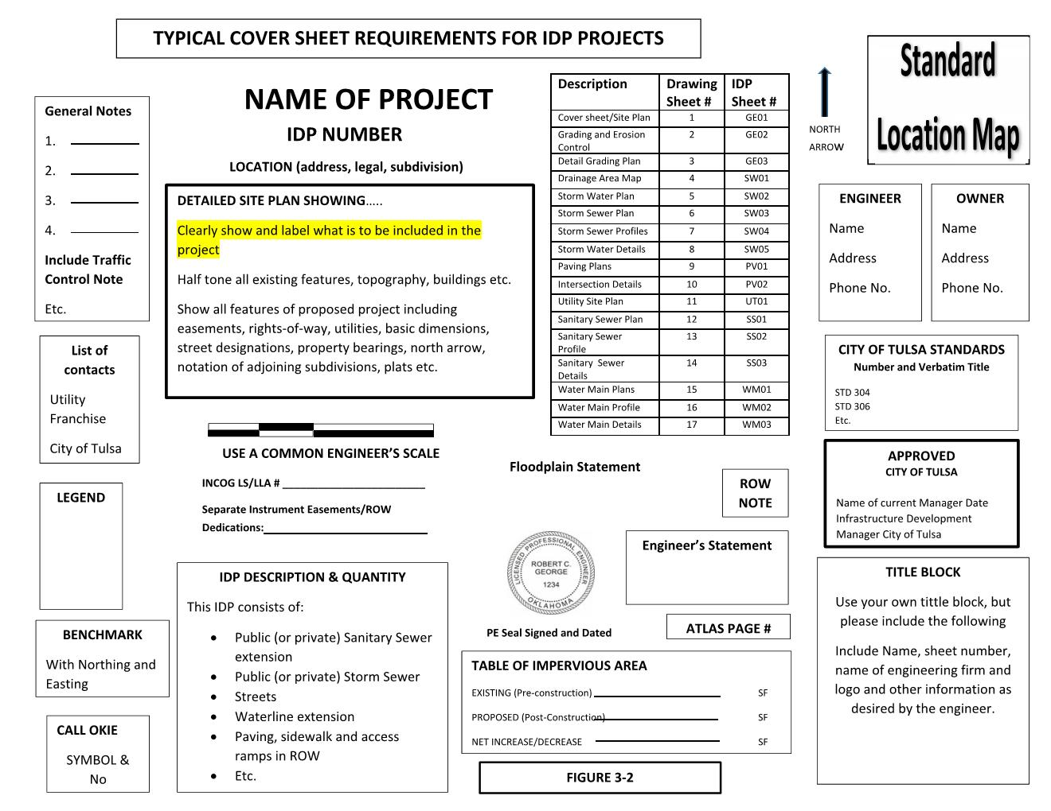
FIGURE 3-2

CITY OF TULSA

INFRASTRUCTURE DEVELOPMENT PROCESS MANUAL

Chapter 400

PERMITS

401 Right-of-Way Permits

When the construction of improvements involves activity in the current or future City Right-of-Way or easements, a permit is required to protect the City’s interest and to ensure that the construction conforms to standards. The City of Tulsa Revised Ordinances related to Rights-of-Way are Title 11, Title 35, and Title 49.

There are three primary categories of permits that may be required.

401.1 IDP Major Construction. All infrastructure that must be designed by a licensed professional engineer, including but not limited to water mains, sanitary sewers, storm sewers, storm drainage, street construction and other such engineering projects, or as may be required by the director.

401.2 Right-of-Way Minor Construction. Any project that can be constructed using standard plans and specifications as outlined by City of Tulsa standards and does not require certification by a licensed professional engineer unless required by Title 11, Chapter 12. Bonding requirements under this category shall depend on whether construction occurs in arterial streets or non-arterial streets. This section shall not apply to “Rights-of-Way Occupants” and their contractor’s as defined in Title 11, Chapter 12.

401.3 Right-of-Way Temporary Use of Streets. The use of non-arterial streets for temporary activity supporting construction, including the placement of equipment or temporary construction accessory buildings, but not including special events permits.

CITY OF TULSA

INFRASTRUCTURE DEVELOPMENT PROCESS MANUAL

Chapter 500

SIGNIFICANT ACTIVITIES IN THE INFRASTRUCTURE DEVELOPMENT PROCESS

501 Privately Developed Public Infrastructure

The process of developing commercial activities such as business parks, retail stores, manufacturing, infrastructure construction for residential development, and others, requires the construction of privately developed public infrastructure. The process includes many subsets of activity that must be managed together to ensure compatibility in the completed project. These activities are an integral part of the commercial construction process and include stormwater drainage, sanitary sewer, water main extensions, easements and rights-of-way, traffic and transportation, and others. This section outlines that process from conception, acceptance of the development and transfer to the City of the privately-constructed facilities as an integral part of the public infrastructure. Figure 5-1, outlines the basic steps in the infrastructure development process.

502 Infrastructure Development Process

502.1 Pre-Development Conference. The development process begins with a consulting engineer and/or owner/developer contacting the Development Services IDP Coordinator, (918) 596-2514, to set up a Pre-Development Conference with City of Tulsa staff members and the Indian Nations Council of Governments (INCOG). A Pre-Development Conference is not mandatory but is strongly recommended and should be held prior to the development of detailed plans. The objective of the meeting is to give the engineer and the owner the opportunity to discuss the project and their plan to proceed with development. Conferences are held on Monday afternoons. 10 Ten days in advance of the meeting, a complete application including site plan in PDF format, showing the proposed development and surrounding property, should be submitted to the IDP Coordinator. See predevelopment meeting application for more details. The conference is attended by all key City staff representing the major, separate categories that must be designed in the project, such as right-of-way, water, sewer, stormwater drainage, traffic, fire suppression, and others. Representatives from INCOG often attend to discuss zoning and platting issues. City and INCOG staff outline the basic infrastructure requirements that must be met in their particular areas of expertise. Agreements made in the pre-development conference should be carried into the design phase. The outcome of the meeting is a commitment by all parties to do their part to make the design of the project conclude successfully. Subsequent to the meeting, the applicant is required to prepare and submit the minutes of the Pre-Development Conference for approval. A copy of the approved minutes is then furnished with the initial submittal of the IDP plans. There is a $350 fee for the conference that is credited towards fees upon IDP plans application (See Title 49 TRO.)

502.2 Zoning and Platting Activities. These activities are regulated by the Tulsa Metropolitan Area Planning Commission (TMAPC) through the Technical Advisory Committee (TAC) of INCOG. The TAC, comprised primarily of city and private utilities staff members, and INCOG staff meet to review plat and related applications for TMAPC and City Council approval, to ensure compliance with City standards as well as zoning and platting regulations. The engineer must consider the recommendations of TAC to ensure compliance or to seek a variance with existing zoning laws or platting requirements. The TMAPC meets regularly to make final decisions regarding TAC recommendations. The TAC and TMAPC meetings are open to the public and dates are published in the local media and may be found on the INCOG website (www.incog.org.)
502.3 Developer’s Contract. The developer is required to enter into a contract with the City of Tulsa and the Tulsa Metropolitan Utility Authority for each project. A completed contract and application must be submitted to the IDP coordinator for processing Provisions of the contract include ensuring that the developer employs a Licensed Professional Engineer under an annual design contract with the City of Tulsa for the duration of the project. The construction contractor(s) must also be under annual contract with the City of Tulsa. The developer must designate a construction coordinator for the duration of the project. It is important that the developer understand that they are responsible and liable for the entire infrastructure until final approval and formal acceptance by the City of Tulsa. The developer must maintain an escrow account with the City of Tulsa to pay for lab testing and inspections, and other costs.

502.4 Project Design. The Engineer must have an active Contract for Annual Engineering Services with the City of Tulsa before design plans will be accepted. The Engineer is responsible for the completion of the plan drawings for submittal, utilizing City of Tulsa design standards where practical. Plans should include enough information to construct all project infrastructure, both public (that which will be turned over to the City upon completion) and private. Plan sets typically include a cover sheet, grading and erosion control plan, drainage plan, drainage area map, storm sewer plan, storm sewer profiles, storm sewer details, paving plan, paving profiles, paving details, and others as needed. Sanitary sewer drawings include plan and profile drawings, sanitary sewer details, and drainage basin maps. Water main drawings also include plan and profile drawings. In addition, each project that requires one acre or more of disturbed earth must include a Stormwater Pollution Prevention Plan (SP3) as required by the Oklahoma Department of Environmental Quality. Projects that have extensive stormwater drainage features must have a Drainage and Detention Report. The Drainage and Detention Report should contain all of the hydrology and hydraulic engineering calculations and analysis required in the design of stormwater facilities for the project. The City of Tulsa requires the 1% runoff to be captured and conveyed either underground or in drainage channels, thereby minimizing the impact on neighboring development. Exceptions are occasionally granted by the Floodplain Administrator. All streets, whether public or private, must be built to City of Tulsa standards and specifications. The Engineer must submit a completed, signed and sealed checklist provided by the City showing that they have completed all requirements for submittal of the design drawings. The Engineer should also submit a copy of the Pre-Development Conference minutes for the record.

502.5 Plan Review. Once the drawings and reports are completed, the Engineer submits a complete application to review IDP plans including a full size set of plans along with an electronic PDF file to the City of Tulsa and the review process begins. The review fees are to be paid by the engineer and are based on the number of sheets in the design plans. The length of time for the review depends on the size and complexity of the project as well as back log. If deficiencies are found by any of the reviewers, a Letter of Deficiency (LOD) is e-mailed to the engineer. The engineer is required to submit a revision application and to respond fully in writing to all LOD comments. If there are any questions, they should be resolved prior to submitting the next design set of drawings. Review staff may be contacted to resolve issues as needed. If the engineer has met the requirements of all reviewers, the plans are approved by the City and signed by the Infrastructure Development Manager. The plans are considered active and approved for construction for up to two years following approval by the City. The developer uses the approved plans to apply for permits for construction, (see section 502.8).

502.6 Supporting Documentation. The City of Tulsa requires the Engineer to provide the SP3, Drainage and Detention Report, ODEQ Engineers Report form and the separate instrument easement documents. If the project requires platting the preliminary plat must me approved by the TMAPC. The developer must pay permit fees and establish an escrow account to pay for inspection services and laboratory testing. When the SP3 report is approved, it is filed for implementation by the Developer.

502.7 Platting. The platting process is managed by INCOG and runs concurrently with the IDP plan approval process.

502.8 Permits for Construction. Generally, two types of construction permits are required in the development process. Right-of-Way Permits are for public infrastructure construction. Building Permits are required for all other construction activities related to residential, commercial and industrial projects. Figure 5-2 shows a timeline relation between site development permits and building permits.

502.8.1 Right-of-Way Permits.
502.8.1.1 IDP Major Construction Permits are issued for all work design and approved through the IDP. The design includes all required infrastructure such as water, sanitary sewer, stormwater drainage structures, streets and sidewalks, and other facilities as required. Permits are issued upon approval of the plans, deposit of appropriate escrow, designation of a construction contractor with an annual contract with the city, and other requirements as needed for the project.
502.8.1.2 Right-of-Way Minor Construction Permits are issued for projects that can be constructed using standard plans and specifications and that do not require certification by a licensed professional engineer.
502.8.1.3 Right-of-Way Temporary Use of Streets Permits are issued for temporary activity supporting construction.

502.8.2 Building Permits. These permits follow a separate process.

502.9 Pre-Work Conference. A pre-work conference is scheduled after the design has been approved and an IDP approved contractor has been selected. The conference is arranged by Field Engineering staff. The objective of the pre-work conference is to ensure that the construction contractor has a clear understanding of the design plans and specifications, and that the project will be built in accordance with those plans. The engineer should be assigned the responsibility to resolve design related construction issues during and following construction and final inspection. The developer shall designate a project coordinator for the duration of the project.

502.10 Construction. The construction contractor(s) selected by the developer must be under an annual contract with the City of Tulsa to perform specific types of work, i.e. water mains, sanitary sewers, storm drain facilities, streets, etc., for the duration of the project. The type of work depends on the contractor’s expertise. The engineer is responsible for design assistance during construction. The developer retains total responsibility for the construction because the construction site remains in private ownership until acceptance by the City. However, if there are portions of the site that are under existing easement or Right-of-Way, the City retains oversight in accordance with City Ordinances. There is a 2-year maintenance period for each significant segment of the contract. The maintenance period for each segment, i.e. storm drainage, sanitary sewer, water mains, etc., begins upon substantial completion of that portion of the project. Upon substantial completion of the final segment of the project and completion of all contract obligations, the City can issue Formal Acceptance of the entire project.

503 Inspection and Testing

503.1 Inspection and Testing. The City performs inspections and testing as the work progresses. The developer must establish an escrow account with the City to pay for the inspections and testing during construction. The City conducts a final inspection of each of the project features upon completion of the infrastructure. Once a specific project feature, i.e. storm sewer, sanitary sewer, water mains, etc., has been inspected and approved, the City issues a certificate of substantial completion, stating that the specific segment of the overall project has been completed to City requirements.

503.2 Maintenance Period. The maintenance period begins upon substantial completion of each segment of the project and is in force for two years. The maintenance bond must be furnished by the contractor for the final segment of the project and assigned to the City of Tulsa. It provides for a two-year warranty that holds the construction contractor responsible for repair or replacement of any structures or facilities as required due to installation errors. The project is considered complete following the two-year maintenance period.

504 Formal Acceptance.

When the entire project has been fully inspected and substantial completion certificates for all IDP items have been issued by the City of Tulsa, the Developer may apply for Formal Acceptance. The project can be legally accepted when record drawings have been submitted, a statement has been filed stating that there are no liens against the project, and the plat and all required easements have been filed. When the City of Tulsa accepts a project, the infrastructure legally becomes the property of the City.

Figure 5-1
CITY OF TULSA

INFRASTRUCTURE DEVELOPMENT PROCESS MANUAL

Chapter 600

CONTRACTS, BONDING, AND INSURANCE

601 Contracts

601.1 Annual Contract for Engineering Services. Every engineering firm desiring to design private development projects within the City of Tulsa that are within the Right-of-Way or area otherwise controlled or will be controlled by the City of Tulsa must enter into an Annual Contract for Engineering Services. The contract is entered into by the City of Tulsa, Tulsa Metropolitan Utility Authority, and the Engineer who expects to be employed by a developer to design infrastructure projects. The Engineer is responsible for preparation of all project plans and specifications and other engineering services during construction of projects started within the year.

The Engineer’s Annual Contract is issued once each year allowing the Engineer to conduct business with the City of Tulsa. It is not project specific. The Engineer must provide assurance that they meet the City’s qualifications that include Professional Engineer
Licensure, professional liability insurance, significant experience doing business with the
City of Tulsa or other metropolitan city, appropriate experience with the types of projects normally planned in the area, and other requirements as determined appropriate.
The Engineer agrees to conform to City of Tulsa Standards in the preparation of plans, specifications, and other contract documents as necessary for the proper construction of the project improvements and provide Record Drawings. The Engineer further agrees to provide periodic general construction supervision of the project through the date of formal acceptance of the infrastructure by the City. (See Appendix A)

601.2 Contractor’s Annual Contract. All construction contractors constructing privately financed infrastructure development within the City of Tulsa must enter into an annual contract with the City. The contract requires a new application each year and must be approved by the City of Tulsa. The contract is specific to the kind of work that the contractor is qualified to undertake, such as water mains, sanitary sewers, storm drainage, streets, and others. The contract also specifies the type of construction permit anticipated, depending on the type and size of work to be completed. The contract is approved by the City of Tulsa and the Tulsa Metropolitan Utility Authority. The contractor is required to obtain the appropriate bonding and insurance.

Should a contractor operating pursuant to an IDP Major Construction Permit report to the Director that the Developer has defaulted on payment to the extent that the Contractor has no reasonable assurance of being paid to complete the project, the Director shall verify the facts. Once it is confirmed that no reasonable assurance can be obtained from the Developer that satisfactory payment arrangements will be made with the Contractor, the Contractor, after stabilizing the construction site to prevent erosion, complying with all applicable ODEQ and EPA regulations, and providing adequate public safety measures as required by the Director, may withdraw from the site without breaching the terms of the City’s annual contract. Any legal questions remaining between the Developer and the Contractor shall be resolved between them without involving the City. (See Appendix C)

601.3 Developer’s Contract. The developer must enter into a contract with the City of Tulsa for each project. The developer must assure that they hire a Licensed Professional Engineer under annual contract with the City of Tulsa. The developer’s contract with the engineer must include engineering design of the project and engineering oversight through formal acceptance of construction by the City. In addition, the developer must use a construction contractor that is under annual contract with the City of Tulsa for the duration of the construction. The developer is responsible for all infrastructure development until Formal Acceptance of the entire project by the City. The City of Tulsa will not issue a Certificate of Occupancy for any building permits until the entire project has been accepted. The developer must maintain an escrow account with the City to pay for inspecting and all lab testing. The developer is required to appoint a construction coordinator for the duration of the project. (See Appendix B)

601.4 The persons authorized to sign on behalf of individuals or the following-listed entities are identified as follows:

Corporations: A legal document may be signed by the corporation's attorney-in-fact, president, vice-president, chairman or vice-chairman of the board of directors. For a document that has been executed by an attorney-in-fact, see the section titled “Execution of documents by an attorney-in-fact” below.
Fiduciary: A court-appointed trustee, receiver, personal representative, guardian, conservator, or other identified fiduciary may be authorized to sign legal documents if the Court Order delegating the authority to the fiduciary provides for such authority to be exercised. A certified copy of the Court Order should be examined by the City Attorney’s Office before accepting any document signed by such fiduciary.

General Partnership: A partner in a general partnership is authorized to sign.
Individuals: An individual may sign personally. An individual who is acting as an attorney-in-fact of a person, typically identified as the “principal” in the power of attorney, may sign on the principal’s behalf if a copy of a properly executed power of attorney is attached or has been provided, and the power of attorney grants the attorney-in-fact the authority to take such action. For a document that has been executed by an attorney-in-fact, see the section titled “Execution of documents by an attorney-in-fact” below.
Limited Liability Company: A manager, member/manager or managing member of a limited liability company is authorized to sign on behalf of a limited liability company. Others specified in the operating agreement or by a resolution of the manager(s) may also sign. If a signatory other than a manager, member/manager or managing member signs a document, the management provisions of the operating agreement should be reviewed to determine who has management authority.
Limited Partnership: The general partner of a limited partnership is authorized to sign.

Public Trust: The President or Chairman of the Board of Trustees of a public trust is typically authorized to sign a document on behalf of the trust. However, the trust indenture for that trust must be examined to ensure that the person executing the document has the authority to do so. The document must be attested by the secretary or assistant secretary of the trust with the seal of the trust impressed or stamped on the document.

Religious Organizations: Execution of a document on behalf of a religious organization such as a church, synagogue or mosque, which is formed as a not-for-profit corporation, should be in proper corporate form as set forth above in “Corporations”. A religious organization can also be formed as a religious corporation, an unincorporated association or a religious society. The articles filed with the Oklahoma Secretary of State, the bylaws and other organizational documents should be examined to determine who has the authority to govern the business affairs of the religious organization and execute documents on its behalf.
School District: A document to be executed on behalf of a school district should be signed by the President of the Board of Education. The Clerk of the Board of Education should attest a conveyance or grant of an interest in real estate (deeds, easements, etc.). If a document signed by the Superintendent of the school district is received, evidence must be provided showing that the Board of Education approved such delegation of authority.

Trust: A trustee of a trust is authorized to sign. If the party who signs is serving as a co-trustee, the trust instrument must be examined to see if a single co-trustee may sign individually or if more than one co-trustee is required. In the alternative, a properly-executed and recorded Memorandum of Trust executed by the currently-serving trustee(s) may be relied upon which sets forth the name of the trust, the date of creation of the trust and the identity of the currently-serving trustee(s). If a successor trustee is signing a document, written evidence, such as a Memorandum of Trust or Affidavit of Successor Trustee must be provided showing that the initial trustee(s) and all prior-named successor trustees are either deceased, have resigned as trustee, or have declined to serve as trustee.

Execution of documents by an attorney-in-fact: If a document is to be executed by an attorney-in-fact of an individual or an entity set forth above, the power of attorney must be dated on or prior to the date the document is signed by the attorney-in-fact. With respect to instruments which will be recorded in the County Clerk’s Office, the power of attorney must be recorded either separately or attached to the instrument being recorded. In each instance, the Power of Attorney will need to be examined by the City Attorney’s Office to determine if the Power of Attorney is in proper form, is in compliance with applicable law, was validly executed and was effective on the date of execution of the instrument by the attorney-in-fact.
Joinder by Spouses: For any contract, easement, or conveyance relating to real estate, the individual with an ownership interest in the real property, as well as the spouse of the person with an ownership interest, if married, must sign the contract, easement, or conveyance. If the individual is a single person, that fact should be recited in the document.
COMMENT: In the event uncertainty exists with regard to the authority of a signer, always check with the Legal Department before accepting the submittal. Signature Authorization. The persons authorized to sign a contract on behalf of the following entities are identified as follows:
602 Bonding

602.1 Annual Right-of-Way Bond (required). Contractors doing private work in the City Right-of-Way must obtain an annual Right-of-Way Bond in the form of a performance, payment, and maintenance bond. Right-of-Way bonds are required for the larger projects within the City Right-of-Way or easements that do not require design by a Licensed Professional Engineer. The bond amount depends on whether the contractor will be working in an arterial street ($250,000 bond) or collector/residential street ($100,000 bond). The Right-of-Way Bonds are shown in, Appendix D.

602.2 Maintenance Bond (required for IDP Major Construction Permit). A maintenance bond for the full value of the work ensures that funding will be available for repairs on the project due to material defects, improper installation or damages caused during construction. The maintenance bond period begins upon approval of the construction of each segment of the project (substantial completion) and extends for 2 years. The bond is the responsibility of the contractor with dual obligation to the developer or the City, depending on ownership of the infrastructure. Ownership of the entire project transfers from the developer to the City upon formal acceptance by the City on the date the acceptance is filed with the City Clerk. For those segments that have not completed the required 2-year maintenance period at the time of acceptance by the City, the maintenance bond obligation transfers from the developer to the City. Bonds must be in a form acceptable to the City and executed by a surety company authorized to do business in the State of Oklahoma guaranteeing all work and materials incorporated in the improvements by the contractor. The maintenance bond is shown in Exhibit C, Appendix D.

603 Insurance and Indemnity

603.1 Engineer Professional Insurance and Indemnity. Every engineering firm entering into a contract with the City of Tulsa for private development must carry professional liability insurance coverage as required by the Laws of the State of Oklahoma. Certificates showing the Engineer is carrying the required insurance must be furnished to the City with the Contract at the time of execution. Certificates of Professional Liability insurance must be maintained in continuous force and effect for a period of three years following final acceptance of the project by the City of Tulsa.

603.2 Contractor’s Insurance. The contractor shall maintain insurance coverage for the period of the annual contract. The contractor must maintain general liability insurance, worker’s compensation insurance, and an owner’s protective liability insurance policy. The minimum amounts of the insurance requirements are:
- Worker’s Compensation Insurance.
- Public Liability Insurance. The contractor must procure and maintain contractor's public liability insurance in the amounts specified in TRO Title 35, Chapter 2 § 202.B.3.b(2).
- Owner's Protection Liability Insurance. The contractor shall also furnish an owner's protective liability policy in the amounts specified in TRO Title 35, Chapter 2 § 202.B.3.b(3).
- Insurance Certificates. The contractor shall furnish the City an original and duplicate certificate of insurance that shall indicate the types of insurance carried and the amounts of coverage. The contractor shall also provide the City with two (2) copies of the policy of insurance issued by the contractor's insurance carrier. TRO Title 35, Chapter 2 § 202.B.3.b(4)
Notice of Cancellation. All insurance policies and certificates must contain clauses stating that the policies cannot be canceled by the insurer without the insurer's providing the City thirty (30) days' prior written notice of cancellation. TRO Title 35, Chapter 2 § 202.B.3.b(5).
CITY OF TULSA

INFRASTRUCTURE DEVELOPMENT PROCESS MANUAL

CHAPTER 700

RESERVED

CITY OF TULSA

INFRASTRUCTURE DEVELOPMENT PROCESS MANUAL

CHAPTER 800

EASEMENTS, RIGHTS-OF-WAY & AGREEMENTS
(Including those created by separate instruments)

801 City of Tulsa Easements
The development of infrastructure in the City of Tulsa may require the establishment of easements to accommodate the public and private utilities, including water, sanitary sewer, stormwater drainage, gas, electric, communications, and others. Easements establish the right of the utility to occupy privately-owned property with certain restrictions on activities within the easement. This chapter discusses various types of easements, the standard location and widths on a typical lot, and the steps to formally establish the easement.

Proposed easements and Rights-of-Way shall be established by either plat or the separate instrument easement process. Platting shall follow the process established by INCOG. The separate instrument easement process is described herein.

IDP Plans must include all existing and proposed Separate Instrument Easements and Rights-of-Way. Existing Easements and Rights-of-Way must be labeled with their type, width and filed Book and Page or Document numbers. In order to protect the interest and infrastructure of the City of Tulsa, all proposed Easements and Rights-of-Way require a field survey conducted under the supervision of a Land Surveyor licensed by the State of Oklahoma. All Separate Instrument Easements shall produce a Plat of Survey adhering to the Minimum Standards for Land Surveying as adopted by the Oklahoma State Board of Licensure for Professional Engineers and Land Surveyors. (See figures 8-1 A-D.)

For Graphical Representation Only

Plat of Survey Example
Interior Easement

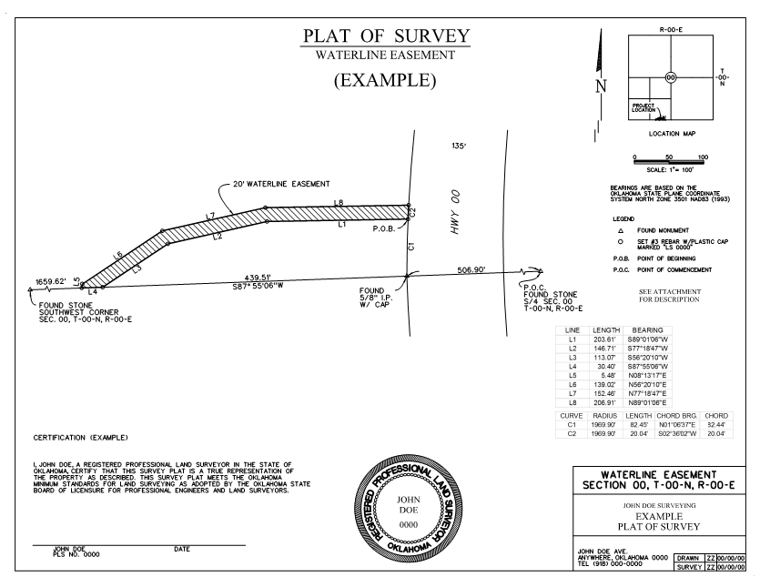
Exhibit 8-1B
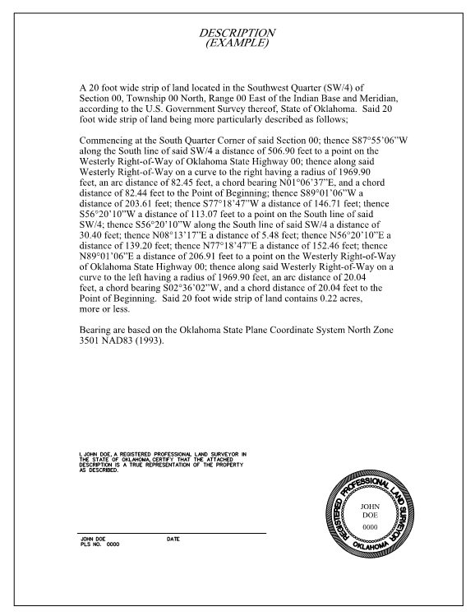
Exhibit 8-1B, Cont.

For Graphical Representation Only
Plat of Survey Example
Easement along Perimeter Line

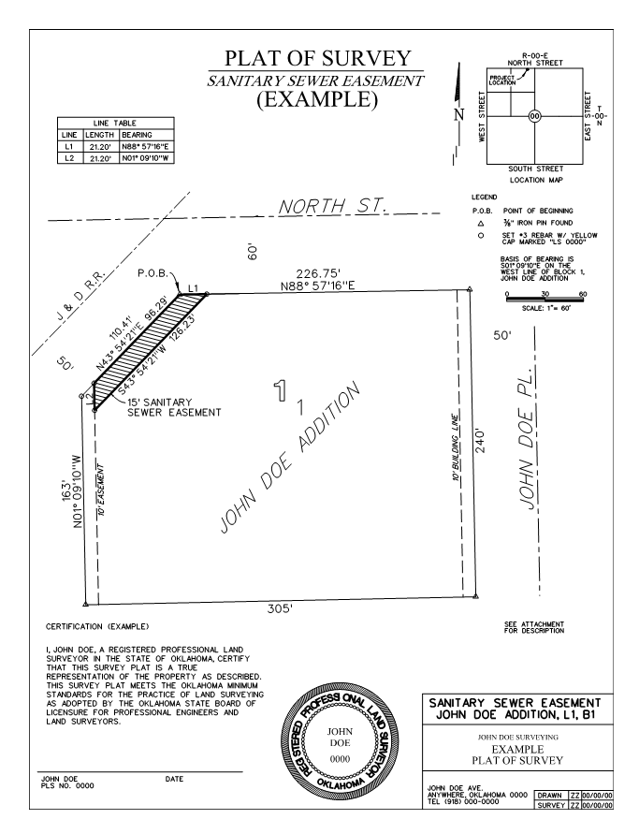
Exhibit 8-1D

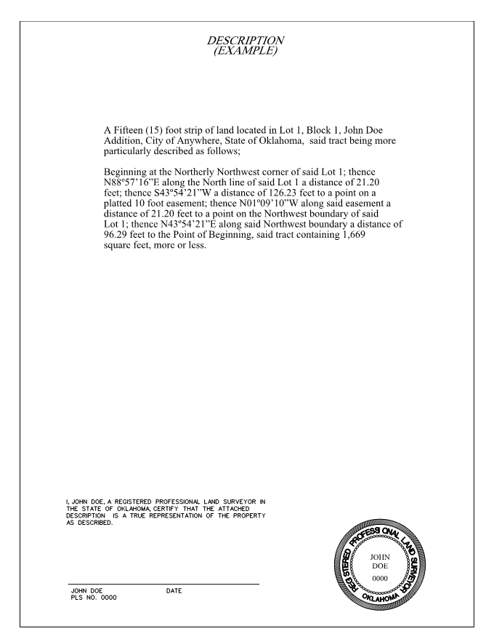
Exhibit 8-1D, Cont.

801.1 Utility Easements. Easements can include poles, wires, conduits, sanitary sewers, stormwater sewers, water mains, gas, power, communication, and other utility lines. Easement widths shall be determined by the need of the utility that required the easement. The standard easement widths are shown on Figure 8-1E and standard utility locations in the easement shown on Figures 8-2 and 8-3.

801.2 Water Main Easements. Water mains are generally located on the south or east side of right-of-way, 8.0 ft. off the property line, unless otherwise approved. Water mains not in a street right-of-way are centered in a minimum 20.0 ft. restricted water line easement.

801.3 Sanitary Sewer Easements. When it is possible, sanitary sewer lines are located in the south or west half of back-to-back easements, 7.0 ft. from the property line. Total back-to-back easement width is 22.0 ft. minimum. Sewer lines are located 12.5 ft. from property line in perimeter easements that are a minimum of 17.5 ft. Any location not standard shall be approved by the City. Side lot easement widths are based on other utilities in the easement and the location and depth of the sewer. A minimum of 7.5 ft. clearance on either side of a side lot line is desired. See Figure 8-4A for minimum sanitary sewer easement widths based on pipe size and depth.

801.4 Drainage Easements. Suitable drainage easements as required by the City standards must be provided on the subdivision plat or provided by separate easement document if the area is not platted. The easement may include stormwater sewers, channels and drainage swales for overland flow, and detention facilities that are above or below ground. Floodwalls, embankments, and other facilities for stormwater management are also included. Storm sewer easements vary according to the size of the pipe and the depth below the ground surface. (Figure 8-4).

Drainage Easements fall into the following categories:

- Storm Sewer – used primarily for underground pipe systems.
- Overland Drainage – used for ditches and swales used to convey stormwater
- Drainage – used for systems that have both an overland and an underground component
- Detention – used for private detention facilities
- Compensatory Storage – used for land designated as compensatory storage floodplain storage.

UTILITY
PERIMETER
EASEMENT
BACK TO BACK
UTILITY
EASEMENT
17.5 FT
11.0 FT
FIGURE 8-1E
STANDARD EASEMENTS

For Graphical Representation Only

For Graphical Representation Only

802 Easement Process.

802.1 Establishing an Easement. Easements can be established either at the time of platting of a property, as an amendment to an existing plat, or by separate instrument on any property. The process for establishing a separate instrument easement within the City of Tulsa is shown below, in addition, see “Required Items for Easements,” Figure 8-5.

- An application with attachments is shown in Appendix E.
- The application is routed within the City of Tulsa.
- The City of Tulsa generates the easement document and returns it to the owner for a notarized signature.
- The signed easement is returned to the City. It is combined with all the other previously submitted documentation and sent through the City process for Mayoral and City Council review.

802.2 Easement Checklist. To ensure prompt processing, follow the guidelines presented in Figure 8-5 and the checkpoints listed below.
- Make sure legal descriptions match the Section, Township and Range.
- Bearings and distances on all lines of the plat unless they are in a table.
- Section ties to be on all plats as well as State Plane coordinates on each corner of the exterior of the plat.
- Tie legal descriptions to section lines wherever possible in the legal documents.
- Include basis of bearings on legal and plot plan
- If a legal description starts in a curve or has non-tangent curves in it then you will need to provide the initial tangent bearing.
- Provide the following information for all curves--
D- Delta
R- Radius
L- Length of curve
- Check closure and location of all legal documents before submitting them.
- Provide an exhibit drawing with all documents showing the area in question.
- Have the legal documents signed by the properly authorized people. Here are a few guidelines to follow:
Every person who grants easements to the City must be at least18 years of age and must sign the easement in front of a notary public. The easement form must clearly state that the individual, corporation, etc., named as the grantor is the owner of the property. In addition, an authorized person must sign the easement form, and the title of the person signing the documents must be shown below the signature unless it is an individual property owner. All signatures must meet the requirements of the Oklahoma Title Examination Standards and will be subject to review and approval by the City of Tulsa Legal Department.
See City website for additional instruction.
802.3 Signature Authorization. The persons authorized to sign easements on behalf of the following entities which are title to the subject land are identified as follows:
Corporations: An easement on land owned by a corporation may be signed by the corporation's attorney-in-fact, president, vice-president, chairman or vice-chairman of the board of directors of the corporation. In order to accept the signature of an attorney-in-fact, he or she will need to attach a copy of his or her power of attorney to prove that the signing person is authorized. The power of attorney must be dated the same date as the document being signed by the authorized individual.

General Partnership: A partner in a general partnership is authorized to sign.

Individuals: Individuals must sign personally. An individual who has another’s "power of attorney" may sign on the principal's behalf if a copy of a properly executed power of attorney is attached. The date of the power of attorney (POA) must be the same as the date of the document being signed by the attorney in fact. If the owner is married, his or her spouse must also sign the easement.

Limited Liability Company: The manager or managing member of a limited liability company is authorized to sign. Others specified in the operating agreement may sign also.

Limited Partnership: The general partner in a limited partnership is authorized to sign.

Religious Corporation: An active Trustee of the board of trustees is authorized to sign. Other officers may be authorized by appropriate corporate papers. If questions exist, the City Attorney’s office should be consulted.

Trust: A trustee of a trust is authorized to sign. If serving as a co-trustee, the trust instrument must be examined to see if a single co-trustee may sign individually or if more than one co-trustee is required. A Memorandum of Trust is required to be recorded prior to the execution of the easement.

Other: A court appointed trustee, receiver, personal representative, guardian, conservator, or other fiduciary may be authorized to sign if the Court Order delegating the authority to the fiduciary provides for such authority to be exercised. A certified copy of the Court Order should be examined by a City Attorney before accepting any document signed by such a fiduciary.

803 Closing and Vacating Easements.

Easements may be either closed or vacated depending on the circumstances.

803.1 Closing an easement: All applications for closing easements or public ways in the City of Tulsa must be filed with the appropriate Director on forms specifically for that purpose. See Title 11 TRO §§ 700 et seq. for the procedure to be followed. The application should include a Plat of Survey, legal description, original purpose of the easement, copy of the easement instrument, name of subdivision and plat number if applicable, reason that the easement should be closed, and additional information called for in the ordinance. If the request is approved, the City will retain the absolute right to re-open any closed easement without expense to the city.

803.2 Vacating an easement: Actions to vacate an easement are filed in District Court following procedures outlined in Title 11 O.S. §§ 42-101 et seq. and Tulsa’s Amended Charter, Article VIII Section 14. Title to the subject property will be clarified in the Court Decree. Tulsa will first pass an ordinance closing the easement before a court action can be filed to vacate the easement and to foreclose the City’s absolute right to reopen it. Often, the Court Decree will reserve an easement in the City or in a utility company for existing infrastructure located within the easement.

804 Existing Utilities Without Recorded Easements

There are areas within the City of Tulsa where utilities are located without an accompanying recorded easement. Many of the older locations of the city include water and sewer lines that were placed before easement policies were established. Every effort is made by the City to locate such utility lines early in the planning phase and before construction begins. However, final responsibility for locating utility lines on property to be developed rests with the owner of the property. When utilities are discovered during construction all parties involved in the construction must stop work and meet with the City to determine the best option to solve the problem. Whether or not a recorded easement is found, the utility will be given the same consideration as if there were a recorded easement in place.

805 Construction Over Easements

The construction of any improvement over a utility easement is not normally allowed without a properly executed agreement on behalf of the City. The applicant must contact the City to start the process of completing an Agreement to Construct in Utility Easement. In general, construction of buildings or structures over easements is not allowed because they interfere with the City’s ability to perform maintenance on the utility line. In addition, maintenance of the line could cause damage to the building or structure which might be considered a liability to the City. Exceptions are defined in Title 11 TRO § 700.

806 License Agreements

Private use or placement of any structure in any Public Way such as a street or other thoroughfare owned by the City and open for public use requires a License Agreement with the City of Tulsa. Typical License Agreements include landscaping, signs, fences, and other beneficial uses. The activity must show that it creates no adverse impacts, provides public benefit, provides aesthetic value, is safe, and does not obstruct public use of the Right-of-Way. Applications for a License Agreement must be filed with the appropriate Director on forms available from the City. The applicant must provide the following:

- The owner(s) of record of the contiguous or property adjoining the public way or publicly owned land;

- A plot, plan or other representative sketch or drawing depicting the proposed improvements, together with construction specifications (when applicable);

- A plat of survey depicting the distances, bearings and points showing the location and area to be covered by Agreement;

- A legal description of that portion of the public way to be covered by Agreement;

- The purpose for which the public way is required for use by the applicant; and

- Such additional information as may be determined by the Director to be necessary for evaluating the application.

The License Agreement must be submitted for consideration to the City Council and Mayor. If it is approved, it is filed and recorded in the land records office of the County Clerk. For more details on obtaining a License Agreement, call Engineering Services at (918) 596-9649.

FIGURE 8-5

REQUIRED ITEMS FOR EASEMENTS

ALL PAGES MUST BE LETTER SIZE (8.5”X11.0”)

1. An Ownership Affidavit from an Abstract Company or letter from an Attorney stating who owns the property.
2. A letter stating who has the right to sign and their title (ie., Owner, Owner and Spouse, President, etc.)
3. A Plan of Survey exhibit (type font must be 12 pt.).
4. A mathematical closure form ensuring that the plat boundaries close.
5. A signed and sealed legal description by a Surveyor (type font must be 12 pt.) and a Certification Statement. The Certification Statement should be as follows:

Example
“I, John Smith, of Smith and Associates, Inc., certify that the attached legal description closes in accord with existing records, is a true representation of the easement/dedication as described, and meets the minimum technical standards for land surveying of the State of Oklahoma.”

______________ _____________________________
Date By: John Smith RPLS No. ??????, State of Oklahoma

Smith and Associates
C. A. No. ????
Expires: 00/00/2020

CITY OF TULSA

INFRASTRUCTURE DEVELOPMENT PROCESS MANUAL

CHAPTER 900

IDP REVIEW PROCESS AND RECORD DRAWINGS

901 Review Process
The process starts before plans are submitted with a recommended pre-development conference attended by all participants in the plan review, including INCOG, Fire Marshal, MTTA, and Planning. After the pre-development conference, the first design review begins upon submittal of detailed plans. If the plans require modification or clarification, the engineer is issued a Letter of Deficiency (LOD). Once the engineer responds and revises the plans as necessary, the process repeats with the initiation of the second design review. After the third design review, if an additional LOD is issued, the engineer and the developer are required to meet with the City of Tulsa staff to review the drawings in an effort to resolve any outstanding issues. The process is limited to four reviews, after which the engineer is required to resubmit as a new project. Each review cycle costs time and money and delays the start of construction of the project. Fewer reviews may be an indication of the engineer’s proficiency, attention to detail, knowledge of City requirements, and reliability to produce quality plans. Unless the project is exceptionally large or complex, the need for four or more reviews indicate the engineer has not achieved the level of competency expected by the City of Tulsa and additional reviews would be costly and time-consuming.

902 Electronic Plan Submittal and Review
The City of Tulsa Development Services has implemented a new electronic content management (ECM) system to better manage documents. The implementation of ECM includes the electronic submittal and review of plans and provides for more efficient and accurate IDP processing. Each submittal must have the appropriate application form. Please follow this procedure:

902.1 Submittal of Plans. Plan submission, including revision, should include 2 sets of full-size drawings and a PDF with comment and markup allowed in the document security.

903 Record Drawings
Permanent hard-copy, Mylar and electronic (pdf) record drawings are required after construction and are currently archived in the City’s Engineering Services Department.

CITY OF TULSA

INFRASTRUCTURE DEVELOPMENT MANUAL

Chapter 1000

INFRASTRUCTURE APPEALS PROCESS

1001 Appeals.

There are several types of appeals in the permitting process. Issues related to the infrastructure development process and design standards must be appealed to the Infrastructure Development Advisory Board (IDAB.) Stormwater management appeals are through the Stormwater Drainage and Hazard Mitigation Advisory Board (SDHMAB).

1002 Infrastructure Development Advisory Board.

The Infrastructure Development Advisory Board (IDAB) assists the City of Tulsa in all aspects of the infrastructure development process except stormwater policies. The IDAB is established and supported by the Development Services Division and advises the appropriate Director on policies, standards, Ordinances, and Codes that relate to infrastructure development within the City. An important responsibility of this Board is to serve as a review alternative for all parties involved in the planning, design, and construction of the infrastructure in support of subdivisions, business parks, and other development. The IDAB does not have the authority to grant variances and resolve disputes between individuals and the City of Tulsa. The IDAB advises the Director and makes recommendations on specific situations regarding infrastructure development. The Board also has the responsibility to review and make recommendations to the Director of Engineering Services on all standards. The Director makes the final decision.

1003 Appeals and Variance Process.

Appeals related to any aspect of the infrastructure development process may be granted as long as it can be shown that they will not cause detriment to the public good, safety or welfare. Any appeal for a variance from established engineering standards must not be contrary to the spirit, purposes and intent of the standards whereby reason of unique and exceptional physical circumstance or condition or a particular property, the literal enforcement of the requirements of the standard would result in an unreasonable hardship. Applications for a variance from City policies must be made by filing a written request with the Development Services Division. Appeals may also be filed electronically to www.tulsaappeals.org. All requests for appeals must go through the Development Services Division who will determine which City of Tulsa Board is the appropriate venue for the appeal. Appeals that are assigned to the Infrastructure Development Advisory Board will be processed accordingly. The written request must meet the following requirements:

- The variance must be the minimum necessary to afford relief.
- The variance must show (1) good and sufficient cause, (2) that failure to grant the variance would result in exceptional hardship to the applicant, (3) and that granting the variance would not result in additional threats to public safety, or extraordinary public expense, nor create nuisances, cause fraud on or victimization of the public, nor conflict with existing local laws or ordinances.
- The appeal process for Infrastructure Development is outlined in Title 35, § 803 which is available on-line at www.cityoftulsa.org. The process is also shown in Figure 10-1. It must be submitted within 20 days of the written decision that is being appealed. Figure 10-2 shows the process for SDHMAB.

APPENDIX A

CONTRACT FOR ANNUAL ENGINEERING SERVICES

Online at: http://www.cityoftulsa.org/media/65551/contract%20for%20annual%20engineering%20services%20with%20sig.pdf

Contract #________

CONTRACT FOR ANNUAL ENGINEERING SERVICES

THIS AGREEMENT, is entered into by and between the CITY OF TULSA, OKLAHOMA, a municipal corporation, (“City”), the Tulsa Municipal Utility Authority (“Authority”) and ________ __________________________, (“Engineer”).

WITNESSETH:

WHEREAS, the ENGINEER in his/her professional capacity desires to contract with third parties, to prepare plans and specifications for water, sanitary sewer, streets, and stormwater facilities, to prepare record drawings of completed projects, and to provide engineering services during the construction of improvements for various projects upon easements and rights-of-ways that are or will be owned or controlled by the City; and

WHEREAS, the ENGINEER is desirous of obtaining the review and approval of the plans and specifications for each project by the Director of Development Services of the City (“Director”); and

WHEREAS, the Authority agrees, and the City is willing to review the plans and specifications prepared by the ENGINEER under the terms and conditions of this contract.

NOW, THEREFORE, in consideration of the promises and covenants contained herein, the parties agree as follows:

- The ENGINEER shall, in conformity with City of Tulsa design criteria, prepare project plans, specifications, and other engineering documents as may be necessary for the proper construction of the project(s), including but not limited to, preparation and documentation of record drawings, and shall perform construction oversight of the project improvements as they are constructed by the Owner and the Owner’s construction contractor(s) until acceptance by the City. The City of Tulsa Standard Specifications for Engineering Services shall be attached and made a part of this contract.
- The City shall review and approve acceptable project plans, specifications, and other engineering documents for the construction of each project prepared and submitted to the Director.
- The ENGINEER shall compensate the City for reviewing and approving project plans and specifications in accordance with the fee schedule established in Title 49, Tulsa Revised Ordinance. Fees shall be due and payable upon presentation of acceptable plans and specifications for each project for review by the City.
- The ENGINEER affirms that Engineer is a Licensed Professional Engineer in the State of Oklahoma at the time of execution of this contract. Should the Engineer cease to be a Licensed Professional Engineer prior to full performance of the terms and conditions of the contract, the Engineer shall immediately cease work and notify the City.
- ENGINEER shall maintain Professional Liability Insurance in limits of not less than $100,000, and such insurance shall remain in continuous force and effect for a period of not less than three years from and after final acceptance of each project.
- ENGINEER shall ensure that all Conditional Letters of Map Revision (CLOMR) and Letters of Map Revision (LOMR), if required for the project, are properly completed and submitted through the City to the Federal Emergency Management Agency.
- This contract shall have a term of twelve months and shall be renewable in successive twelve-month intervals beginning on the anniversary of the contract each year thereafter upon the agreement of the Authority, the City and the Engineer.

IN TESTIMONY WHEREOF, the parties have caused this Agreement to be executed by their duly authorized officers or representatives on the dates set forth below.

ENGINEERING FIRM

Name of Firm:____________________________ Type of Firm________________________

By________________________________ Executed on this ________day of _______, 20___.

Signature: _______________________________________________________________

 | President |  | Vice President |  | Manager |  | Owner |  | Other _______

TULSA METROPOLITAN UTILITY AUTHORITY

By___________________________ Executed on this _______day of________, 20___.
Chairman

By___________________________ Executed on this _______day of________, 20___.
Secretary

APPROVED:

By___________________________ Executed on this ________day of _______, 20___.
Attorney for Tulsa Metropolitan
Utility Authority

CITY OF TULSA, OKLAHOMA, a municipal corporation

By___________________________ Executed on this ________day of _______, 20___.
Mayor
ATTEST:

By___________________________ Executed on this ________ day of ______, 20___.
City Clerk

APPROVED:

By___________________________ Executed on this _____ day of _______, 20___.
City Attorney
APPENDIX B

DEVELOPER’S CONTRACT
Online at: http://www.cityoftulsa.org/media/65548/developers%20contract%20with%20sig.pdf

Contract #_______________

DEVELOPER’S CONTRACT

WHEREAS,______________________________________________________,
(Name of Developer)

Indicate type of legal entity:

Corporation Partnership

LLC Other_______________

is undertaking the construction of an infrastructure development hereafter referred to as “Project” described as:
(Internal Use Only)
Development Name:_____________________________ Development No._______________

Location of Development___________________________________________________; and

WITNESSETH:

WHEREAS, the DEVELOPER desires to design, construct, and transfer to the City of Tulsa (CITY) the above infrastructure development within CITY in compliance with all CITY requirements which include the types of construction listed below:

Check each block that applies:

Sanitary Sewers Water Mains

Stormwater Drainage Facilities Streets &/or Sidewalks

Other, Specify_____________

and,
WHEREAS, the DEVELOPER understands he must obtain the required zoning, platting, right-of way, and easements as required for the above development, and

WHEREAS, the DEVELOPER has expressed the desire to obtain CITY approval of design, inspection, and other services for the above development, and

WHEREAS, the DEVELOPER understands he must have record drawings submitted for the above development to CITY, and
WHEREAS, the DEVELOPER understands that he must allow and pay for inspections, laboratory testing, and other fees as required by CITY, and

WHEREAS, all costs of the subject development shall be borne by DEVELOPER, holding CITY harmless from same; and

WHEREAS, CITY is willing to provide design review for the above development, approve acceptable plans, provide inspection services, provide or arrange for laboratory testing, and receive record drawings.

NOW, THEREFORE, in consideration of the promises and covenants contained herein, the parties agree as follows:

- The DEVELOPER shall hire an engineer currently under annual contract with CITY to design and oversee construction through completion of the development and its formal acceptance by CITY.
- The DEVELOPER shall construct the water system, sanitary sewer, storm drains, streets, and all other infrastructure development as required by and in accordance with the engineer’s design and in compliance with CITY standards utilizing a construction contractor(s) currently under annual contract with CITY, and

The DEVELOPER shall maintain an escrow account with CITY to pay for lab testing, inspecting, ODEQ fees, connection costs, and other fees, and

- The DEVELOPER shall ensure that all Conditional Letters of Map Revision (CLOMR) and Letters of Map Revision (LOMR) (if required for the development) are properly completed and submitted in a timely manner through the City to the Federal Emergency Management Agency for approval.

- The DEVELOPER shall remain responsible and accountable for all requirements until formal acceptance of the development by CITY. Formal acceptance by CITY shall not occur until all infrastructure construction is complete, final inspection, delivery to CITY of all the record drawings, receipt from DEVELOPER of certification that there are no liens against the development, and the issuance by the City Engineer of written acceptance of the development.

- The DEVELOPER, if appropriate, shall enter into an additional contract provision to construct oversize water mains as directed by the City to accommodate future development outside the area covered by this development for which the DEVELOPER will be reimbursed according to the provisions of the contract.

- The DEVELOPER, if appropriate, shall enter into additional contract provisions to construct oversize sanitary sewer mains as directed by the City to accommodate future development outside the area covered by this development for which the DEVELOPER will be reimbursed according to the provisions of the contract.

- The DEVELOPER shall cause to be delivered record drawings to CITY to show the work as actually constructed before the development will be formally accepted by the City.
- The DEVELOPER shall identify for CITY a construction coordinator who will serve for the duration of the development.

- EXCLUSIVE RIGHT OF CITY: It is agreed that CITY is granted exclusive access to the infrastructure for operation and maintenance following substantial completion through formal acceptance of the development.

IN TESTIMONY WHEREOF, the parties have caused this Contract to be executed by their duly authorized officers of representatives on the dates set forth below.

The following addendums are part of this contract (If required):
Addendum A. Water Main Excess Capacity w/ repayment
Addendum B. Sanitary Sewer Excess Capacity

DEVELOPER

Name of Firm:________________________ Type of Firm________________________

By____________________________ Executed on this ________day of _______, 20___.

Signature: _______________________________________________________________

President Vice President Manager Owner Other___________

TULSA METROPOLITAN UTILITY AUTHORITY

By___________________________ Executed on this _______day of________, 20___.
Chairman

By___________________________ Executed on this _______day of________, 20___.
Secretary

APPROVED:

By___________________________ Executed on this ________day of _______, 20___.
Attorney for Tulsa Metropolitan
Utility Authority

CITY OF TULSA, OKLAHOMA, a municipal corporation

By______________________ Executed on this _____ day of __________, 20___.
Mayor

ATTEST:

By ______________________
City Clerk

APPROVED:

By______________________ Executed on this ________day of _______, 20___.
City Attorney

APPENDIX C

ANNUAL CONTRACT
FOR CONTRACTORS TO CONSTRUCT
INFRASTRUCTURE DEVELOPMENT
WITHIN THE CITY OF TULSA, OKLAHOMA
Online at: http://www.cityoftulsa.org/media/75491/contractors%20contract%20with%20sig.pdf

ANNUAL CONTRACT

FOR CONTRACTORS TO CONSTRUCT
INFRASTRUCTURE DEVELOPMENT
WITHIN THE RIGHT-OF-WAY OF THE
CITY OF TULSA, OKLAHOMA

THIS CONTRACT made by and between____________________________________, herein called “CONTRACTOR”, the TULSA METROPOLITAN UTILITY AUTHORITY, and the CITY OF TULSA, OKLAHOMA, a Municipal Corporation, herein called “CITY”.

WITNESSETH:

WHEREAS, CONTRACTOR desires to engage in construction related to infrastructure development within the City which includes the types of construction listed below:

Check each block that applies:

Sanitary Sewers Water Mains

Stormwater Drainage Facilities Streets

Other, Specify_____________

WHEREAS, CITY’S applicable infrastructure development ordinances, Title 35 TRO §§100 et seq, provide that an annual contract with CITY is a prerequisite to performing such work; and

WHEREAS, CONTRACTOR agrees to conduct the above construction activities in a good, substantial, and workmanlike manner as required by and in accordance with the engineer’s design and in compliance with all CITY Codes and Standards; and

WHEREAS, whether CONTRACTOR engages in construction which requires an IDP Major Construction permit or Right-of-Way Minor Construction Permit, as described and provided in Title 35 TRO §§ 100 et seq, or any other construction as required by ordinance, CONTRACTOR agrees to first satisfy all bond and insurance requirements set out herein; and

WHEREAS, the Authority agrees and the CITY desires to enter into this annual contract with CONTRACTOR which authorizes CONTRACTOR to pursue such construction.

NOW, THEREFORE, in consideration of the promises and covenants contained in this Contract, the parties agree as follows:

- CONTRACTOR shall, (a) furnish all tools, equipment, supplies, superintendence, transportation, and other construction accessories, services, and facilities; (b) furnish all materials, supplies, and equipment specified and required to be incorporated in and to form a permanent part of the completed work; (c) provide and perform all such materials and labor in a good, substantial, and workmanlike manner and in accordance with the requirements, stipulations, provisions, and conditions of the contract documents for the construction of a specific infrastructure development project within CITY.

2. CONTRACTOR shall, prior to initiation of construction, post with CITY either an Arterial Right-of-Way Bond in the amount of $250,000 for work in an arterial street or a Non-Arterial Right -of-Way Bond in the amount of $100,000 for work in a non-arterial street, executed by a surety company approved by CITY to guarantee the project during construction and for a period of one (1) year after final inspection/approval by CITY. Each Major Construction development shall require a two (2) year maintenance bond.

2.A Should a contractor operating pursuant to an IDP Major Construction Permit report to the Director of Development Services, that the Developer has defaulted on payment to the extent that the Contractor has no reasonable assurance of being paid to complete the project, the Director shall verify the facts. Once it is confirmed that no reasonable assurance can be obtained from the Developer that satisfactory payment arrangements will be made with the Contractor, the Contractor, after stabilizing the construction site to prevent erosion; complying with all applicable ODEQ and EPA regulations; and providing adequate public safety measures as required by the Director of Development Services, may withdraw from the site without breaching the terms of this contract. Any legal questions remaining between the Developer and the Contractor shall be resolved between them without involving the City.

3. CONTRACTOR shall maintain insurance coverage for the one-year period following final inspection/approval of the project by CITY including general liability, worker’s compensation, and owner’s protective liability insurance as required by ordinance in Title 35 TRO.

4. CITY shall recognize CONTRACTOR as having secured this annual contract as a prerequisite to being issued an IDP Major Construction or Right-of-Way Minor Construction Permit or other Permit contemplated in Title 35 TRO.

5. Whether engaged in construction which requires a an IDP Major Construction or Right-of-Way Minor Construction Permit as contemplated in Title 35 TRO, CONTRACTOR shall comply with all insurance and bond requirements set out therein. Failure to replace insurance or bonds prior to cancellation shall terminate the rights under this contract.

6. CONTRACTOR shall look to the owner/developer who engages CONTRACTOR for full payment for CONTRACTOR’S services, etc. and not look to Authority or CITY for compensation of any nature.

7. This contract shall have a twelve (12) month term either to be renewed or replaced on the anniversary date for successive twelve (12) month intervals should contractor satisfy then existing CITY requirements. The anniversary date shall be twelve (12) months from the date this contract is approved by the Mayor. Should the contractor authorized by this contract initiate a project while this contract is in effect he/she may complete the project within a reasonable time notwithstanding that a new annual contract has not been obtained, provided that the continued construction is insured and bonded as required by ordinance. No new projects may be initiated after the expiration of the term of this contract.

IN TESTIMONY WHEREOF, the parties have caused this Agreement to be executed by their duly authorized officers of representatives on the dates set forth below.

CONTRACTOR:

Name of Firm:________________________ Type of Firm_______________________

By____________________________ Executed on this ________day of _______, 20___.

Signature: _______________________________________________________________

President Vice President Manager Owner Other___________

TULSA METROPOLITAN UTILITY AUTHORITY

By___________________________ Executed on this _______day of________, 20___.
Chairman

By___________________________ Executed on this _______day of________, 20___.
Secretary

APPROVED:

By___________________________ Executed on this ________day of _______, 20___.
Attorney for Tulsa Metropolitan
Utility Authority

CITY OF TULSA, OKLAHOMA, a municipal corporation

By___________________________ Executed on this ________day of _______, 20___.
Mayor
ATTEST:

By___________________________
City Clerk

APPROVED:

By___________________________ Executed on this ________day of _______, 20___.
City Attorney

APPENDIX D

BONDS

EXHIBIT A

ANNUAL BOND FOR
IDP MAJOR CONSTRUCTION OR
RIGHT-OF-WAY MINOR CONSTRUCTION ARTERIAL
CITY OF TULSA
175 E. 2nd Street, Suite 450
Tulsa, OK 74103

Bond Number Principal

______________ ________________________

Annual Contract #_________________________

KNOW ALL MEN BY THESE PRESENTS: THAT WE, _____________________________, as Principal and ____________________________, as Surety, are held and firmly bound unto the City of Tulsa, Oklahoma (hereinafter called City), and unto the property owner making any private contracts with said Principal, or unto either of said parties in the sum of $250,000.00 to be paid to City or to the said property owner and or material men and subcontractors as hereafter provided for which payment we do hereby bind ourselves, our heirs, executors, administrators, and assigns, jointly and severally, by these presents.

THE TERM AND CONDITION of this obligation are such, that whereas the Principal is hereby duly permitted by City, to carry on the business of constructing various improvements within ARTERIAL STREETS, as well as all other rights-of-way and easements within City for a twelve month period following the Principal’s annual contract with the City dated the _____ day of ________, 20____, extending, if applicable, through a twelve month warranty period per project approved by City.

NOW, THEREFORE, if Principal, in the construction of the projects being permitted so to do by an annual contract with City and having contracted to carry out the construction, shall conform strictly to all the requirements of law, including the ordinances of City applicable thereto; shall construct the project in accordance with the engineer’s design, if applicable, and the standard plans and specifications adopted by City; shall pay all damages which may occur because of any defective or inferior workmanship or materials in any such structure which he may construct or shall repair or replace same provided such defective condition becomes evident before the end of the one-year guarantee period, which in no case will be less than one year from approval by City of the project; and shall pay any and all legal claims for labor, material, machinery, or equipment furnished for the work specified in any such contract, then these presents shall be void; otherwise, they shall remain in full force and effect.

CANCELLATION: This bond may be cancelled by the Principal or the Surety upon giving written notice to the Director of Development Services of the intention to effect cancellation. Cancellation shall be effective no sooner than thirty (30) days from the date of the written acknowledgement of receipt of the notice signed by the Director of Development Services.

Cancellation shall not impact the Surety’s obligations hereunder as applied to all work commenced and/or completed prior to the effective date of cancellation.

Cancellation shall impact only such obligations of the Surety that would have arisen on work not yet commenced prior to the effective date of cancellation.

NON-STACKING OF COVERAGE: The coverage provided by this Bond is attached to the City of Tulsa Annual Contract # ________________ and is limited to work commenced during the time covered by said contract. Coverage is not subject to accumulation (stacking) due to any additional or subsequently signed contracts.

All work in the public right-of-way shall be guaranteed free from defects for a period of one year after approval by City.

The authority of Principal to continue to carry on the business of constructing the project shall terminate upon completion of the one-year warranty period.

Major construction projects shall require a separate two (2) year Maintenance Bond as provided by ordinance.
IN WITNESS WHEREOF, the said Principal has caused this bond to be executed in its name, and the said Surety has caused this bond to be executed in its name and its corporate seal to be hereunto affixed by its attorney-in-fact, duly authorized to do so, on this _____ day of __________, 20___.

(If Corporation)
_______________________________________
ATTEST:
Principal

________________________________ By:___________________________________
Secretary Title: (please check appropriate box below)

(seal)
□ President □ Vice-President □ Manager

                     □ Individual □ Other: ______________

_______________________________________
Surety

By: ___________________________________
Attorney-in-fact

APPROVED AS TO FORM, THIS ______ day of __________________, 20___.

_______________________________________
Assistant City Attorney

NOTE: Date of Bond must not be prior to date of Contract. Surety companies executing bonds must appear on the State Insurance Department’s most current Annual Report, and be authorized to transact business in Oklahoma.

EXHIBIT B

ANNUAL BOND FOR
IDP MAJOR CONSTRUCTION OR
RIGHT-OF-WAY MINOR CONSTRUCTION NON-ARTERIAL
CITY OF TULSA
175 E. 2nd Street, Suite 450
Tulsa, OK 74103

Bond Number Principal

______________ ________________________

Annual Contract #_______________________

KNOW ALL MEN BY THESE PRESENTS: THAT WE, _____________________________, as Principal and ____________________________, as Surety, are held and firmly bound unto the City of Tulsa, Oklahoma (hereinafter called City), and unto the property owner making any private contracts with said Principal, or unto either of said parties in the sum of $100,000.00 to be paid to City or to the said property owner and or material men and subcontractors as hereafter provided for which payment we do hereby bind ourselves, our heirs, executors, administrators, and assigns, jointly and severally, by these presents.
THE TERM AND CONDITION of this obligation are such, that whereas the Principal is hereby duly permitted by City, to carry on the business of constructing various improvements within NON-ARTERIAL STREETS, and other NON-ARTERIAL rights-o f-way and easements within City for a twelve month period following the Principal’s annual contract with the City dated the _____ day of ___________, 20_____, extending, if applicable, through a twelve month warranty period per project accepted by City.

NOW, THEREFORE, if Principal, in the construction of the projects being permitted so to do by an annual contract with City and having contracted to carry out the construction, shall conform strictly to all the requirements of law, including the ordinances of City applicable thereto; shall construct the project in accordance with the engineer’s design, if applicable, standard plans and specifications adopted by City; shall pay all damages which may occur because of any defective or inferior workmanship or materials in any such structure which he may construct or shall repair or replace same provided such defective condition becomes evident before the end of the one-year guarantee period, which in no case will be less than one year from approval by City of the project; and shall pay any and all legal claims for labor, material, machinery, or equipment furnished for the work, then these presents shall be void; otherwise, they shall remain in full force and effect.

CANCELLATION: This bond may be cancelled by the Principal or the Surety upon giving written notice to the Director of Development Services of the intention to effect cancellation. Cancellation shall be effective no sooner than thirty (30) days from the date of the written acknowledgement of receipt of the notice signed by the Director of Development Services.

Cancellation shall not impact the Surety’s obligations hereunder as applied to all work commenced and/or completed prior to the effective date of cancellation.

Cancellation shall impact only such obligations of the Surety that would have arisen on work not yet commenced prior to the effective date of cancellation.

NON-STACKING OF COVERAGE: The coverage provided by this Bond is attached to the City of Tulsa Annual Contract # ________________ and is limited to work commenced during the time covered by said contract. Coverage is not subject to accumulation (stacking) due to any additional or subsequently signed contracts.

All work in the public right-of-way shall be guaranteed free from defects for a period of one year after approval by City.

The authority of Principal to continue to carry on the business of constructing the project shall terminate upon completion of the one-year warranty period.

IN WITNESS WHEREOF, the said Principal has caused this bond to be executed in its name, and the said Surety has caused this bond to be executed in its name and its corporate seal to be hereunto affixed by its attorney-in-fact, duly authorized to do so, on this _____ day of __________, 20___.

(If Corporation)
_______________________________________
ATTEST:
Principal

_________________________________ By:________________________________
Secretary Title: (please check appropriate box below)

(seal)
□ President □ Vice-President □ Manager

                      □ Individual □ Other: _______________

__________________________________
Surety

By: ___________________________________
Attorney-in-fact

APPROVED AS TO FORM, THIS ______ day of __________________, 20___.

________________________________
Assistant City Attorney

NOTE: Date of Bond must not be prior to date of Contract. Surety companies executing bonds must appear on the State Insurance Department’s most current Annual Report, and be authorized to transact business in Oklahoma.

EXHIBIT C

IDP MAJOR CONSTRUCTION
MAINTENANCE BOND
CITY OF TULSA
175 E. 2nd Street, Suite 450
Tulsa, OK 74103

Bond Number Project

______________ Name: ____________________Number: ___________________
(Internal use only)
Type of construction included in this bond, check each block that applies:

Sanitary Sewers Water Mains

Stormwater Drainage Facilities Streets

Other, Specify_____________

The above construction being an element of the ________________________development.

KNOW ALL MEN BY THESE PRESENTS: THAT WE, __________________________, as Principal and ____________________________, as Surety, are held and firmly bound unto the City of Tulsa, Oklahoma (hereinafter called City), and unto __________________________, the Developer, or unto either of said parties in the sum of $_______________, 100% of the estimated cost of the above named project as shown in the contract for its construction, to be paid to City or to the Developer (obligees)for which payment we do hereby bind ourselves, our and each of our heirs, executors, administrators, and assigns, jointly and severally, firmly by these presents.
THE CONDITION of this obligation is such, that whereas on the _____ day of __________, 20___, Principal was permitted by City, to carry on the business of constructing the above mentioned project within or to be within the right-of-way and easements within said City, through completion of the project and for a period of two years following substantial completion of the project.

NOW, THEREFORE, if said Principal shall pay or cause to be paid to the obligees all damage, loss, and expense which may result by reason of defective materials and/or workmanship in connection with said work, and latent defects occurring within a period of two (2) years from and after substantial completion of said project, then this obligation shall be null and void, otherwise to be and remain in full force and effect. Should this two-year warranty period extend beyond formal acceptance of the ___________________________________ development by the City, the Developer shall be the obligee prior to formal acceptance, thereafter, the City shall be the obligee.

The Surety, for value received, hereby stipulates and agrees that no change, extension of time, alteration or addition to the terms of the contract or to the work to be performed thereunder, or the specifications accompanying same, shall in any way affect its obligation on this bond; and it does hereby waive notice of any such change, extension of time, alteration or addition of the terms of the contract, or to the work or to the specifications.

The authority of Principal to continue to carry on the business of constructing the project on the right-of-way and easements within the City shall terminate upon completion of the two-year warranty period.

IN WITNESS WHEREOF, the said Principal has caused this bond to be executed in its name, and the said Surety has caused this bond to be executed in its name and its corporate seal to be hereunto affixed by its attorney-in-fact, duly authorized to do so, on this _____ day of __________, 20___.

(If Corporation)

ATTEST:
Principal

_________________________________ By: ____________________________________
Secretary Title: (please check appropriate box below)

(seal)
                      □ President □ Vice-President □ Manager

                       □Individual □Other:___________________

___________________________________
Surety

By:__________________________________
Attorney-in-fact

APPROVED AS TO FORM, THIS ______ day of __________________, 20___.

_____________________________________
Assistant City Attorney

APPENDIX E

INFRASTRUCTURE DEVELOPMENT APPLICATIONS

Online at http://www.cityoftulsa.org/our-city/doing-business-with-the-city/permits-and-licensing/infrastructure-development.aspx

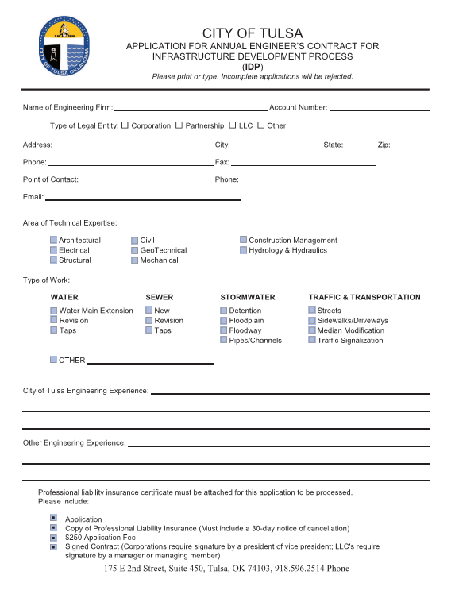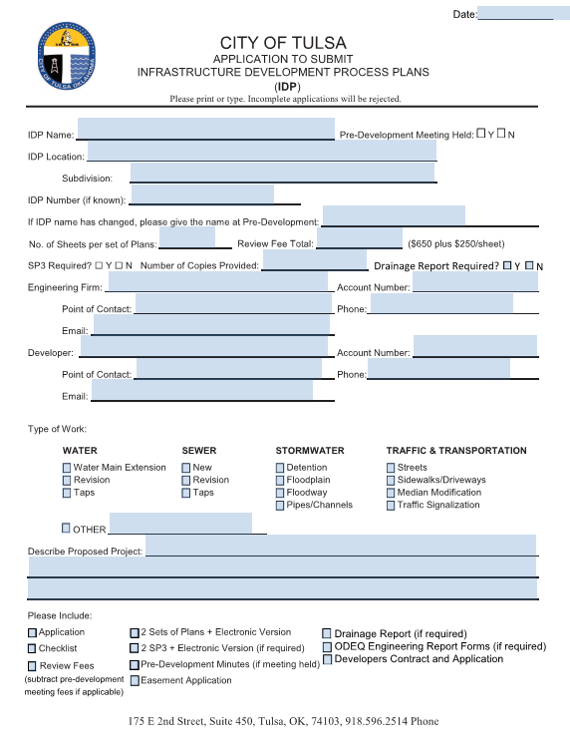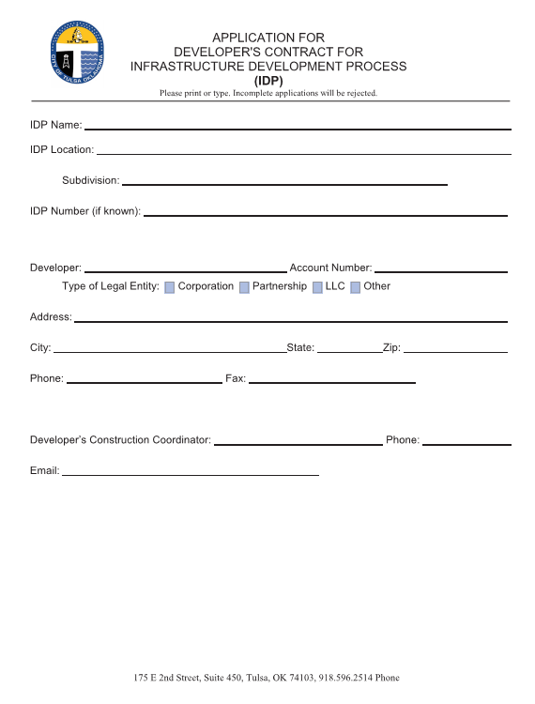 SEE WEBSITE FOR CURRENT VERSION
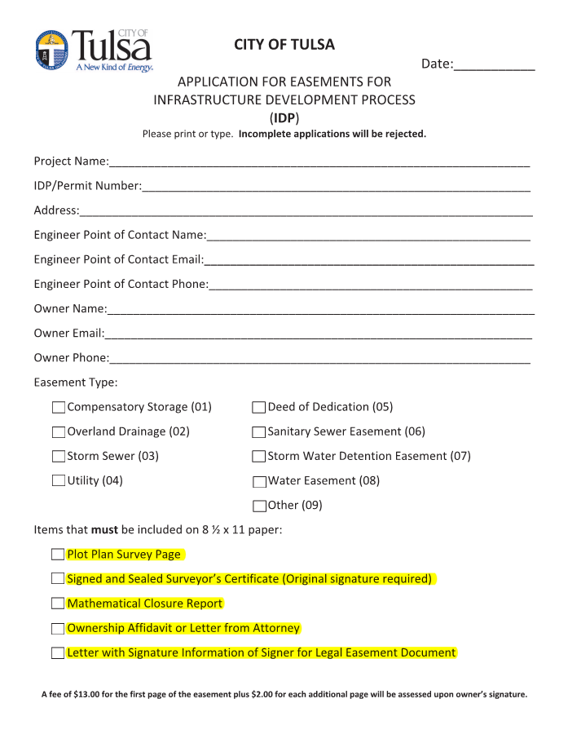

SEE WEBSITE FOR CURRENT VERSION

REQUIRED ITEMS FOR EASEMENTS

ALL PAGES MUST BE LETTER SIZE (8.5”X11.0”)

1. An Ownership Affidavit from an Abstract Company or letter from an Attorney stating who owns the property.
2. A letter stating who will sign and their title (ie., Owner, Owner and Spouse, President, etc.)
3. A Plan of Survey exhibit (type font must be 12 pt.).
4. A mathematical closure form ensuring that the plat boundaries close.
5. A signed and sealed legal description by a Surveyor (type font must be 12 pt.) and a Certification Statement. The Certification Statement should be as follows:

Example
“I, John Smith, of Smith and Associates, Inc., certify that the attached legal description closes in accord with existing records, is a true representation of the easement/dedication as described, and meets the minimum technical standards for land surveying of the State of Oklahoma.”

______________ _____________________________
Date By: John Smith RPLS No. ??????, State of Oklahoma

Smith and Associates
C. A. No. ????
Expires: 00/00/2020

To ensure prompt processing the following should also be checked before turning in an easement.
- Make sure legal descriptions match the Section, Township and Range.
- Bearings and distances on ALL lines of the plat unless they are in a table.
- Section ties to be on all plats and State Plane coordinates on each corner of the exterior of the plat.
- Tie legal descriptions to section lines WHEREVER possible in the legal documents.
- If a legal description starts in a curve or has non-tangent curves in it then you will need to provide the initial tangent bearing.
- Provide the following information for ALL curves—
  - D-Delta
  - R-Radius
  - L-Length of curve
- CHECK CLOSURE AND LOCATION of ALL legal documents before submitting them.
- Have all the necessary easements turned in and approved before requesting a Permit.
- Provide an EXHIBIT drawing with ALL documents showing the area in question.

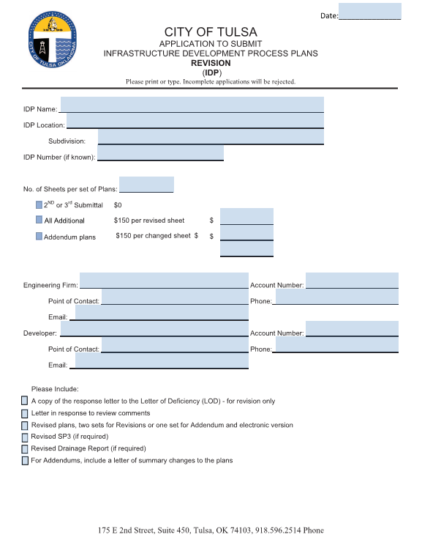
SEE WEBSITE FOR CURRENT VERSION

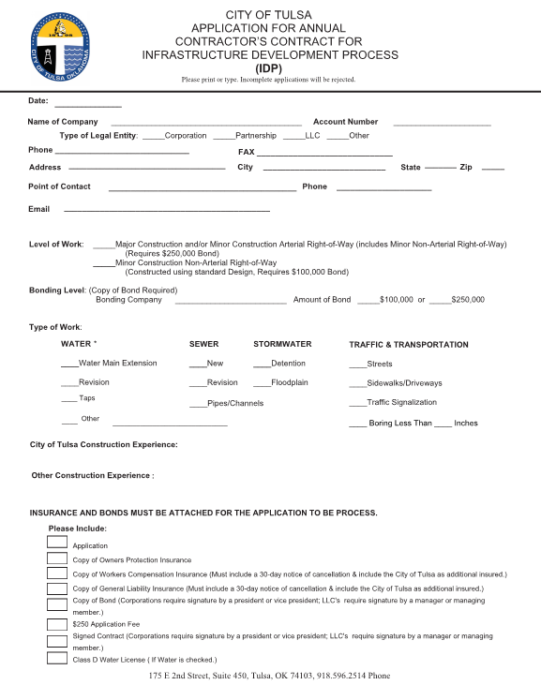
SEE WEBSITE FOR CURRENT VERSION
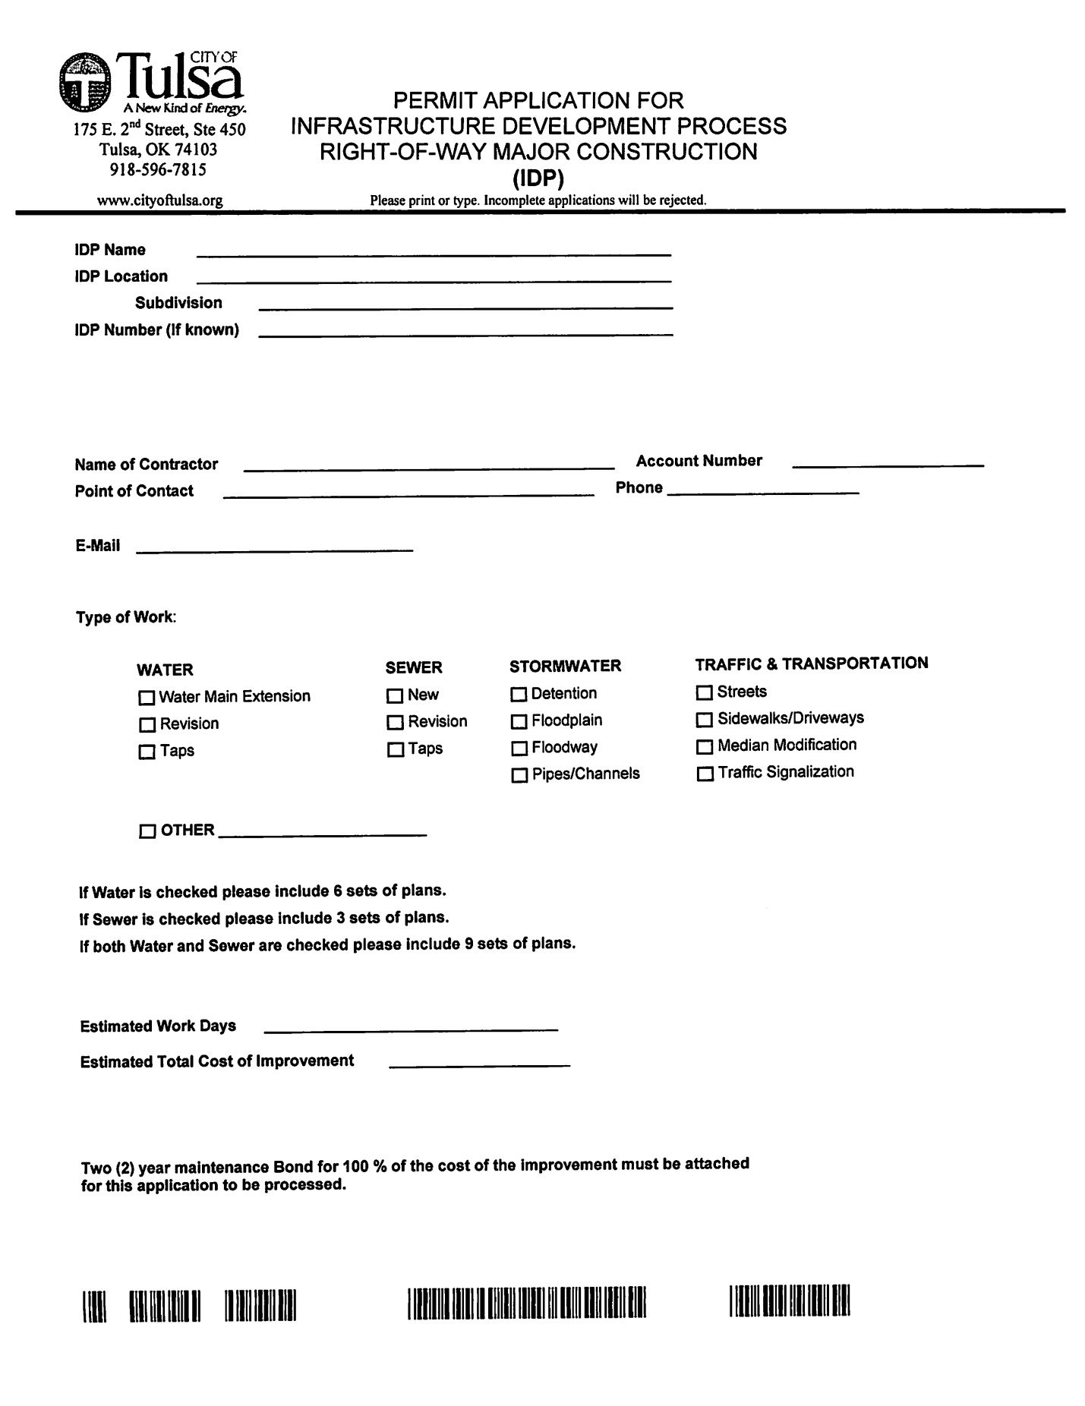
SEE WEBSITE FOR CURRENT VERSION

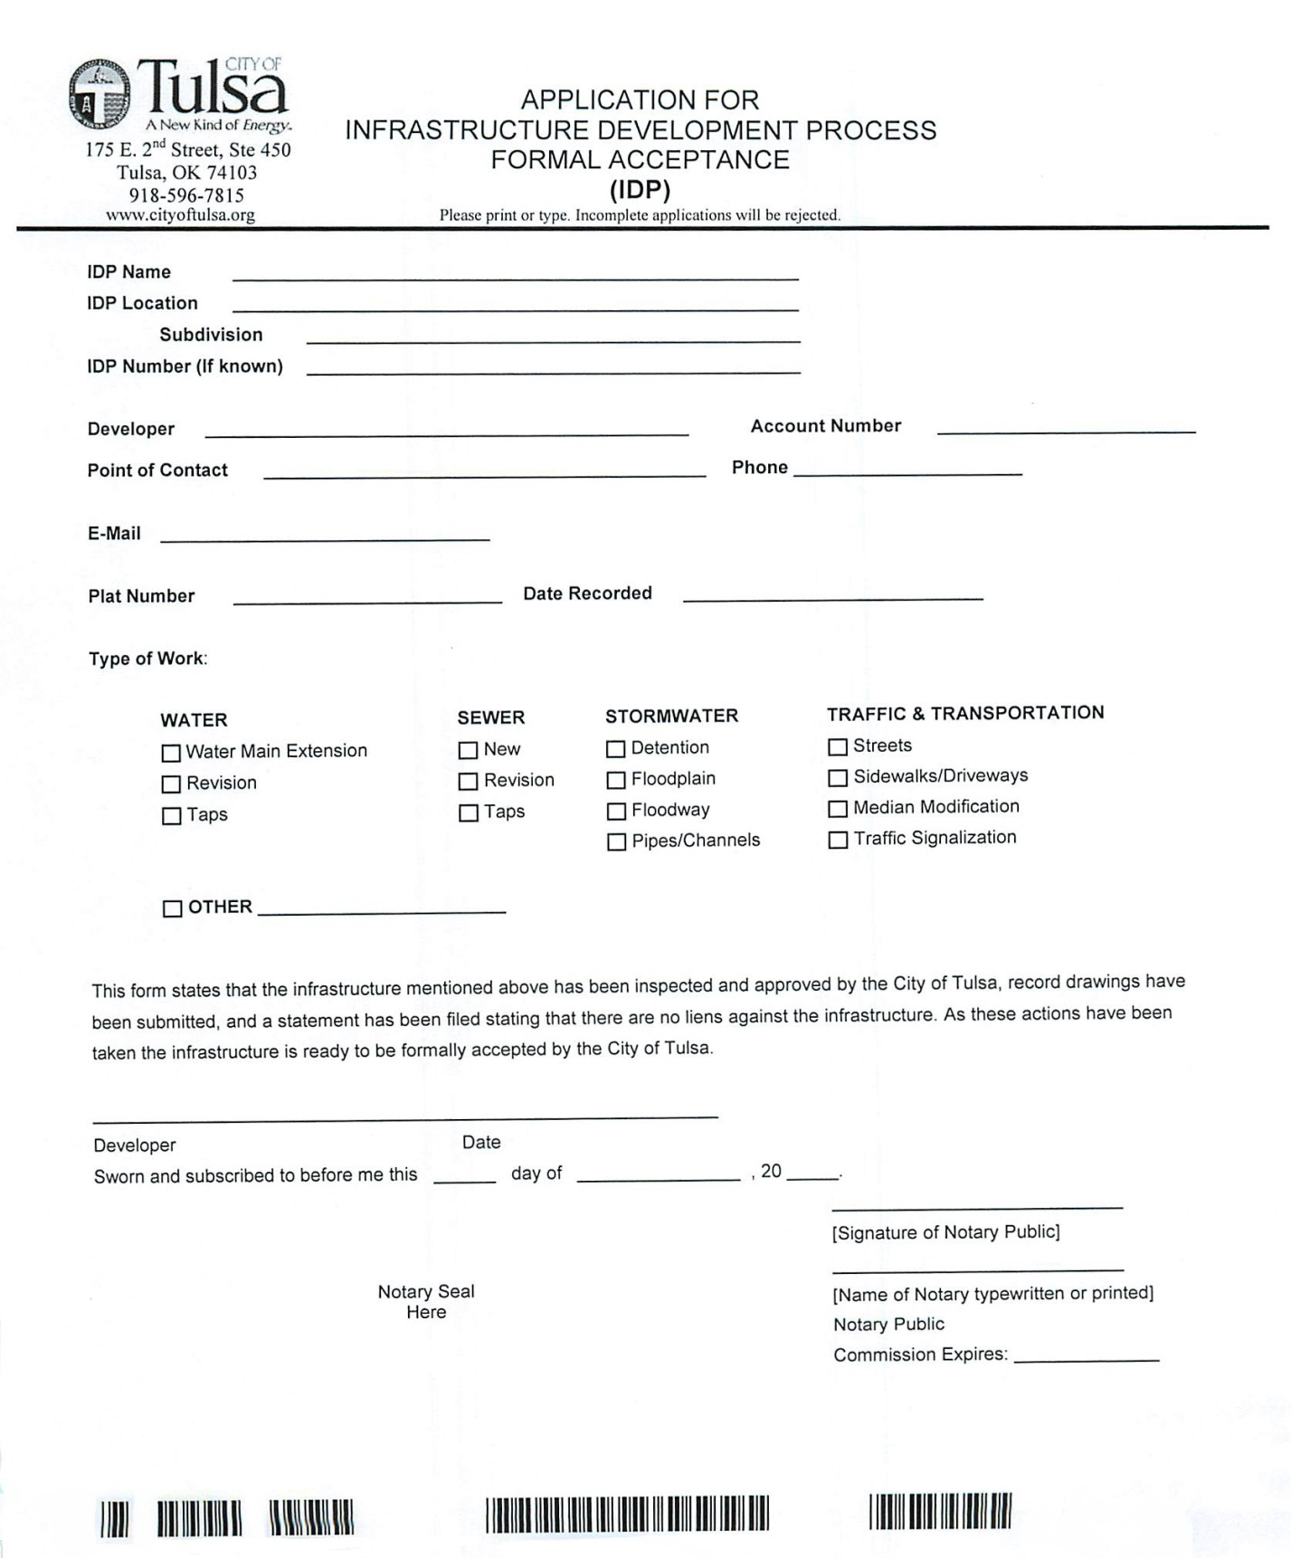
SEE WEBSITE FOR CURRENT VERSION

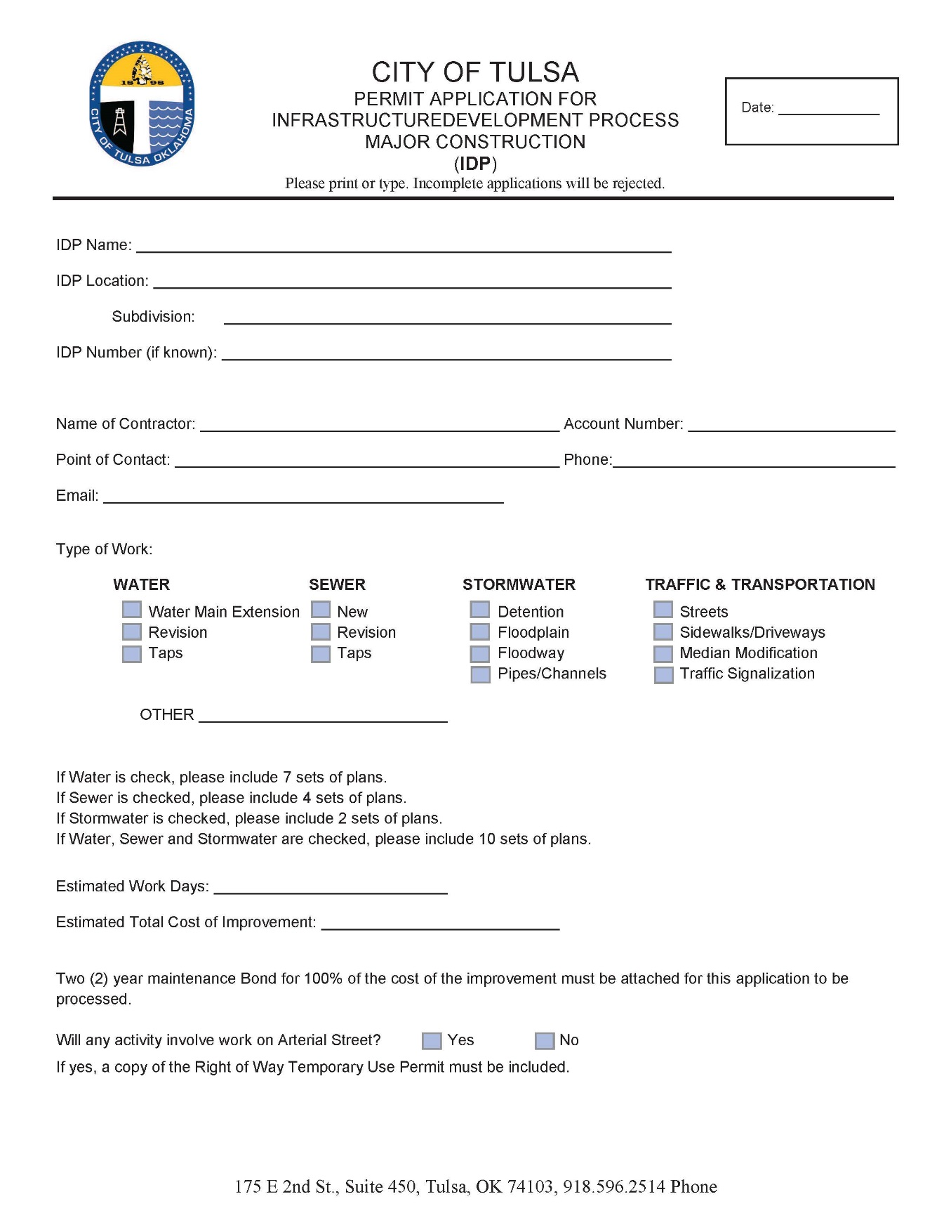

SEE WEBSITE FOR CURRENT VERSION

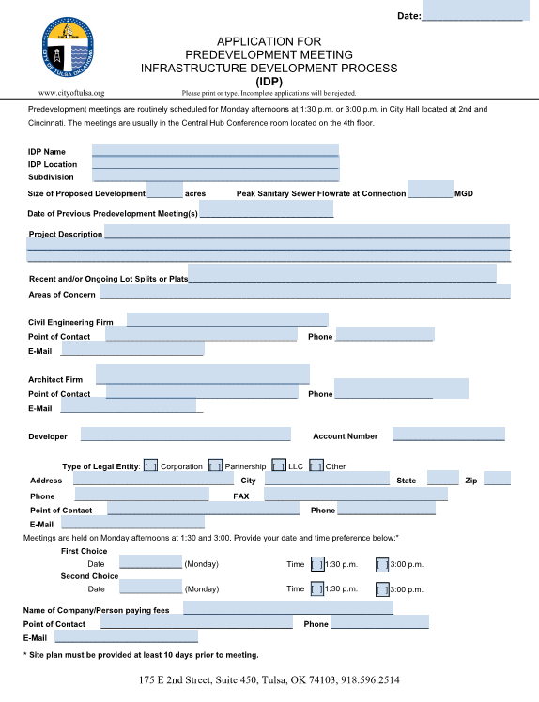
SEE WEBSITE FOR CURRENT VERSION

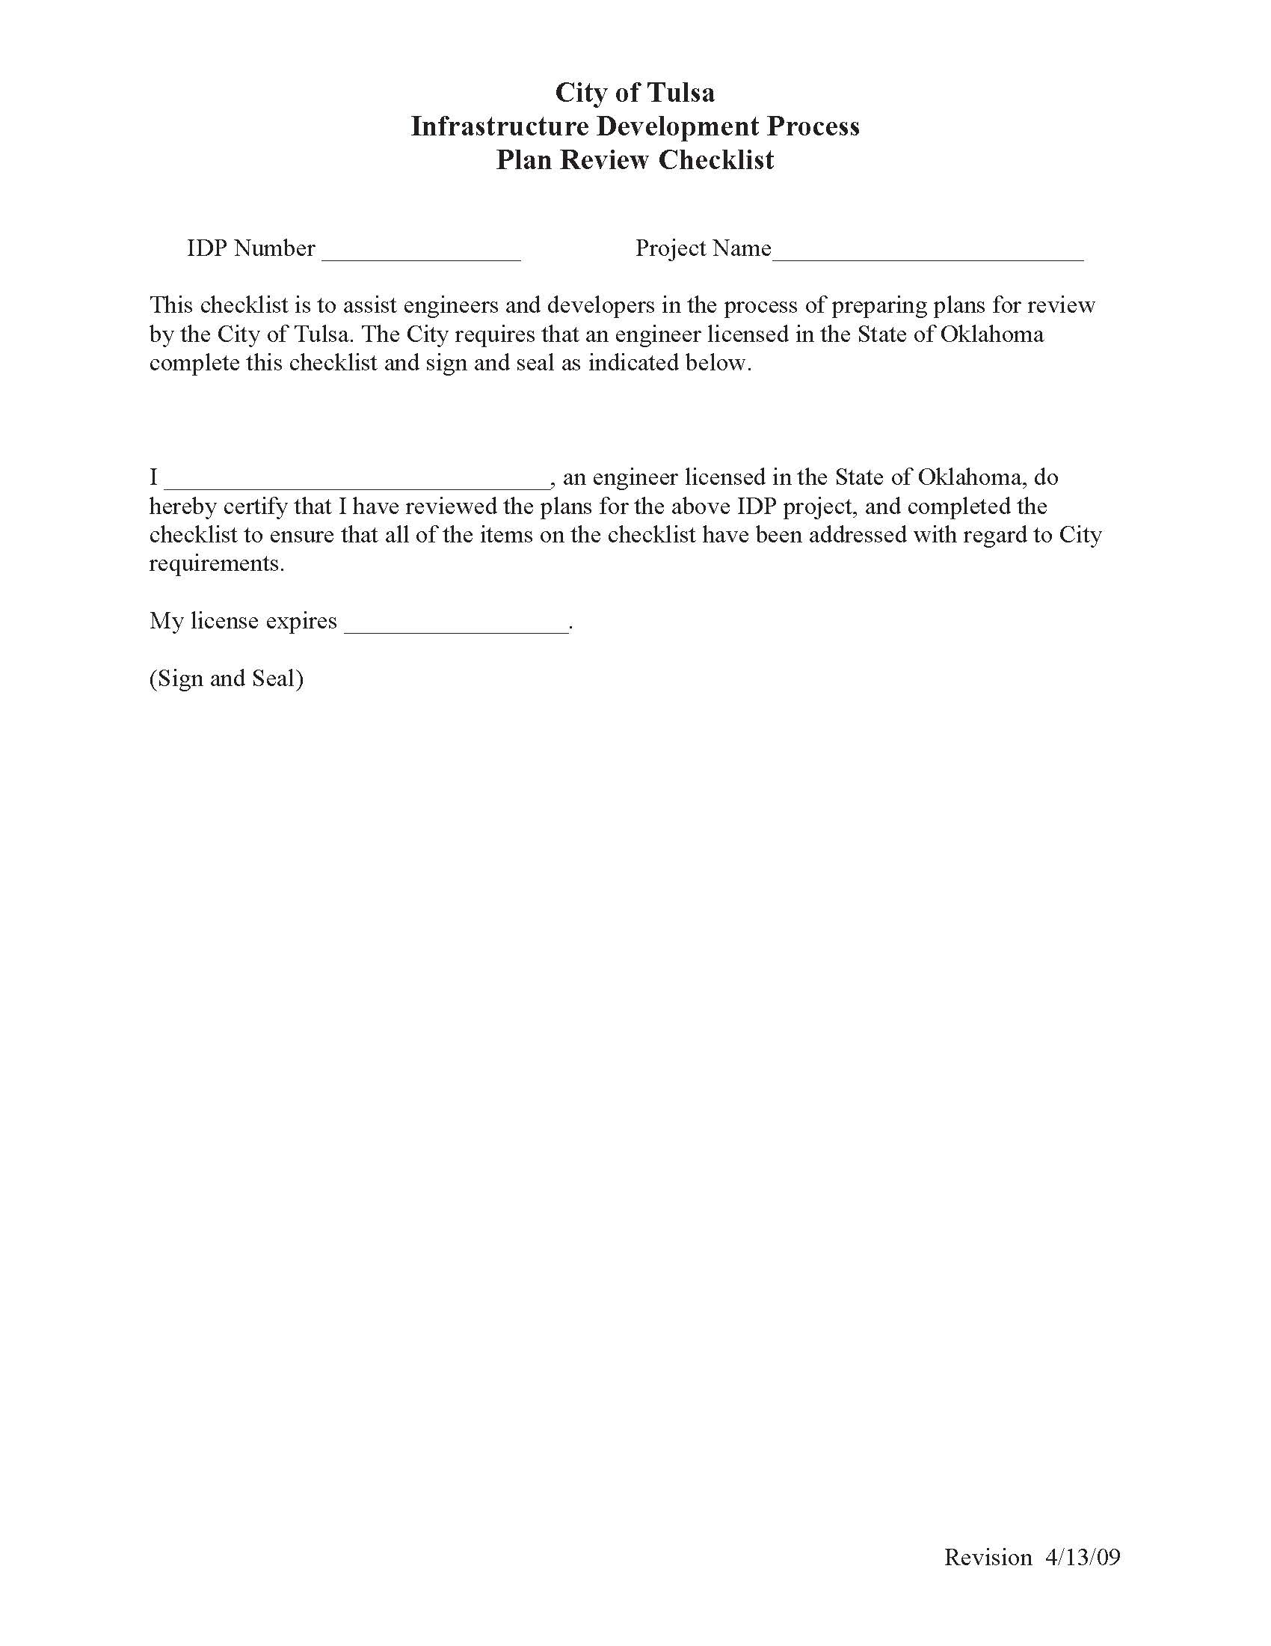SEE WEBSITE FOR CURRENT VERSION

APPENDIX F
COORDINATION ENTITIES

Federal Emergency Management Agency (FEMA)
FEMA is responsible for the implementation of the National Flood Insurance Program of which the City of Tulsa is a participating community. FEMA contracts with the ISO to review each participating community to determine their level of implementing their floodplain management program and gives them a numerical rating. Those communities that have the best ratings receive significant reductions in their flood insurance premiums.
Indian Nations
Due to their unique status with the Federal Government, the Indian Nations in Oklahoma (Creek, Cherokee, and Osage in the City of Tulsa) are recognized as Sovereign Nations. The City of Tulsa has no authority to permit the Sovereign Nation’s development activity, however the City may regulate all connections to the public system.
Indian Nations Council of Governments (INCOG)
INCOG is a voluntary association of local governments serving Creek, Osage, Tulsa, Rogers, and Wagoner counties. INCOG is the implementation organization for the Tulsa Metropolitan Area Planning Commission for the development and administration of zoning codes. INCOG employs professional planning staff for both City of Tulsa and Tulsa County Boards of Adjustment in zoning implementation.
Oklahoma Department of Environmental Quality (ODEQ)
ODEQ is the permitting authority for the majority of wastewater discharges within the State of Oklahoma under the authority of the Oklahoma Pollutant Discharge Elimination System Act. In that regard, ODEQ requires the submittal of Stormwater Pollution Prevention Plans (SP3) for all projects that disturb a surface area of one acre or more. The City of Tulsa has been delegated approval authority for SP3s. ODEQ is also the regulatory agency for onsite waste water disposal systems.
Oklahoma State Department of Health (OSDH)
The OSDH administers the public health statutes ensuring a safe water supply, food service, immunizations, and other aspects of community health. All water and sewer systems, including individual waste water disposal systems, in the City of Tulsa must be constructed in compliance with applicable OSDH standards or the more stringent standards of the City.
Oklahoma Department of Transportation (ODOT)
ODOT sets design standards for all State of Oklahoma highways. The City of Tulsa utilizes ODOT standards on City streets where appropriate. The City coordinates the design of all streets that join State highways. Any development that encroached on ODOT Right-of-Way must have permission from ODOT.
Oklahoma Turnpike Authority (OTA)
OTA sets design standards for all State of Oklahoma turnpikes. The City of Tulsa utilizes OTA standards on City streets where appropriate. The City coordinates the design of all streets that join State turnpikes. Any development encroaching OTA Right-of-Way must have permission from OTA.
Oklahoma Water Resources Board (OWRB)
The OWRB effectively and efficiently manages, protects and improves the water resources of the state and plans for Oklahoma’s long-range water needs in a responsive, innovative, and professional manner.
State Historic Preservation Office (SHPO)
The SHPO identifies, evaluates, and nominates properties for listing on the National Register of Historic Places. The National Register is a catalogue of buildings, sites, structures, districts, and objects significant in our past. The SHPO is also responsible for implementing Section 106 of the National Historic Preservation Act which requires federal agencies to consider the effects of their undertakings on properties listed in or eligible for the National Register of Historic Places.
Tulsa Health Department
The Tulsa Health Department enforces the public health and sanitation ordinances of the City of Tulsa, issues permits for health related activities, issues permits to construct, repair, or install septic tank systems. The Tulsa Health Department also administers all aspects of public health including immunizations, testing and screening, health related education, environmental health issues, safe drinking water, sanitation and others.
Tulsa Metropolitan Area Planning Commission (TMAPC)
The TMAPC is responsible for ensuring orderly development in both the City of Tulsa and Tulsa County. Administration of the Zoning Code, review of subdivision regulations, establishment of building lines and setback requirements, and long range planning, are just a few of TMAPC’s responsibilities. TMAPC makes recommendations on all rezoning cases. The recommendations are forwarded to either the City Council or the County Commission, depending on jurisdiction, for final action. TMAPC also exercises the power and authority to review, approve and disapprove plats for the subdivision of land pursuant to the powers and jurisdiction vested through Title 19, Oklahoma Statutes, 863.9.
Tulsa Metropolitan Utility Authority (TMUA)
The Tulsa Metropolitan Utility Authority is a public trust organization created by city charter. TMUA's primary responsibilities are to manage, construct, and maintain Tulsa's water works and sanitary sewer systems, and to fix rates for water and sewer services rendered within its boundaries.
Tulsa, Osage, Wagoner, Creek and Rogers Counties
Interface with the City of Tulsa in numerous areas including water and sewer systems, streets, storm drains and others.
Tulsa-West Tulsa Levee Districts No. 12 & 13
A branch of Tulsa County government established with the sole purpose of providing for the maintenance of the Tulsa-West Tulsa Levee system constructed by the Federal Government in the 1950’s. The levee system is 33 miles long on both sides of the Arkansas River from Sand Springs to Jenks. The levee districts have the authority to assess property owners to pay for annual maintenance of the levees.
US Army Corps of Engineers (USACE)
This Federal agency is responsible for implementing Section 404 of the Federal water Pollution Control Act Amendments, 1972. This is the wetland statute that governs the use of lands that meet the Federal definition of a wetland. The Corps is also responsible for implementation of Section 10 for dredge and fill of navigable streams. The flow of water in the Arkansas River at Tulsa is regulated by releases from Keystone Dam upstream, which is a Corps of Engineers project.
US Environmental Protection Agency (EPA)
EPA implements air and water quality standards in all communities thereby restricting the use of Federal funding in those communities that rate poorly in such standards as ozone in the air and pollutants in area streams. EPA also sets standards for drinking water at the tap. The National Environmental Policy Act which requires Environmental Impact Statements and other actions for projects funded with Federal appropriations is also monitored and enforced by the EPA
US Fish and Wildlife Service (USFWS)
The USFWS is responsible for implementation of the Endangered Species Act which has authority over any property that is utilized by any species on the Endangered Species list, and has jurisdiction over the environmental impacts of any activity funded with Federal money. The USFWS also has the responsibility for enforcing Federal laws regulating the Environmental Corridor along the Arkansas River. The Environmental Corridor is a mile-wide corridor along each bank of the Arkansas River through Tulsa that is protected to preserve the wildlife habitat and scenic aesthetic values of the river. The USFWS has regulatory authority for all proposed activity within this border.

APPENDIX G
GUIDING LEGAL AUTHORITY

General
The City of Tulsa’s legal authority to conduct business started with its official
Charter granted by the Governor of the new State of Oklahoma in 1907. The Charter has subsequently been amended several times. The City has also adopted other legal instruments that govern how the City conducts all aspects of development. Construction within the city limits of Tulsa is legally guided by Codes and Ordinances.

Codes
Codes Codes are generally those guidelines that have been accepted nationally and internationally as the proven method and design to accomplish a specific task. The International Code Council establishes updates and publishes all codes. Codes ensure uniformity of standards around the international community. The codes that are utilized by the City of Tulsa include:

International Building Code (IBC)
International Existing Building Code (IEBC)
International Residential Code (IRC)
International Fire Code (IFC)
International Mechanical Code (IMC)
International Plumbing Code (IPC)
National Electric Code (NEC)

Please see the City of Tulsa web page for the latest codes that have been adopted by the City.
Zoning Codes. Zoning Codes for the City are established by the Indian Nations Council of Governments (INCOG) and codified in Tulsa City Ordinance, Title 42, Zoning and Property Restrictions. The codes determine the classification of each individual property within the City limits. Changes in Zoning Code classifications must be brought before INCOG for processing.
Americans with Disabilities Act. Accessibility for the disabled in all projects and development in the City of Tulsa shall be provided in compliance with the prevailing International Building Code and the referenced standards for accessibility. All projects must comply with Americans with Disabilities Act and Architectural Barriers Act Accessibility Guidelines (July 23, 2004). The City of Tulsa will enforce the American National Standards Institute (ANSI) standards as adopted by the IBC codes.

Ordinances
The City of Tulsa Ordinances are the specific legal authority for all aspects of government business. Ordinances are approved by the Mayor and the City Council, thereby becoming law. The above-mentioned International Codes that are applicable to the City are adopted as law through Ordinances that adopt a specific Code. Other Ordinances that are passed by the City Council address other specific issues or needs required for the City to conduct its business. The Ordinances can be found on the City’s web page. The primary Ordinances that relate to the permitting of construction projects are as follows:
- Title 5-------Boards, Commissions & Committees
- Title 11-----Public Works Department
- Title 11A---Stormwater Drainage
- Title 11C---Waterworks and Sewerage
- Title 14-----Fire Prevention Code
- Title 17-----Health Regulations
- Title 18-----Insurance & Bonds
- Title 35-----Infrastructure Development
- Title 42-----Zoning and Property Restrictions
- Title 49-----Administrative Permit and License Fees
- Title 51-----Building Code
- Title 52-----Electrical Code
- Title 56-----Plumbing Code
- Title 59-----Mechanical Code

Policies
As changes occur in processes, procedures, or standards that impact the way the City of Tulsa does business, policy statements are issued. Policy Statements are issued by the appropriate Director and inform the public and City employees of the change so that they may be incorporated into the applicable business area. A current listing of policy statements can be found on the City of Tulsa web page at www.cityoftulsa.org.

